

Software Requirement specification
Industrial Challenge Project

Date | Name | Work | Version
12/06/2009 | Abdullah Arslan | Document creation  1th section. | V 1.0
12/07/09 | Waseem Soomro | Use-Cases moved into SRS | V 1.0
12/07/09 | Waseem Soomro | 1.3 Definitions, Abbreviations | V 1.0
12/09/09 | Shobha BC,  Tigran Harutyunyan  Gilana Ramezani  Abdollah Tabareh | Refined Use Cases | V 1.1
12/10/09 | Shobha BC | Changed the alternate path follows, numbering of uses format and created 4 more use cases. | V1.2
09/12/2009 | Mustafa Al-Zubaidi | Reviewed SRS document | V1.2
11/12/2009 | Abdullah Arslan  Mustafa Al-Zubaidi | Created Activity Diagram | V1.2
13/12/2009 | Shobha B C | Fixed the defects raised for use cases | V1.2
13/12/2009 | Shobha B C | Corrected Constraints and Assumptions (2.2), Overall Description (2.1),  Purpose (1.1), Scope(1.2), References(1.4), and also  Revised on 3.1, 3.2 | V1.2
17/09/09 | Shobha BC,  Tigran Harutyunyan  Gilana Ramezani | Refined Use Cases | V 1.3
Revision History

Contents
1 Introduction 5
1.1 Purpose 5
1.2 Scope 5
1.3 Definitions, Abbreviations 5
1.4 References 6
2 System Over view 6
2.1 Overall Description 6
2.2 Constraints and Assumptions 6
3 Functional Requirements 6
3.1 Actors 7
3.2 Use Case Diagram 7
3.3 Use Cases 7
3.3.1 Create crisis (use-case) 8
3.3.2 Edit crisis (use-case) 9
3.3.3 Close Crisis (use-case) 9
3.3.4 Create Incident (use-case) 10
3.3.5 Edit Incident (use-case) 10
3.3.6 Create Request (use-case) 11
3.3.7 Edit Request (use-case) 12
3.3.8 Answer Request (use-case) 12
3.3.9 Manager login (use-case) 13
3.3.10 Volunteer login by mobile (use-case) 13
3.3.11 Manager Registration (use-case) 14
3.3.12 Volunteer Registration (use-case) 14
3.3.13 Volunteer edits profile (use-case) 15
3.3.14 Create Statistical Report (use-case) 16
3.3.15 Report Incident (use-case) 16
3.3.16 Send Alert (use-case) 17
3.3.17 Report Incident Progress 17
3.3.18 Search Volunteers (use-case) 18
3.3.19 View Volunteers’ Incident Report (use-case) 19
3.3.20 View Incident Information (use-case) 19
3.3.21 Close Incident (use-case) 20
3.3.22 Volunteer Profile Login (use-case) 20
3.3.23 Get Alert (use-case) 21
3.3.24 View Crisis (use-case) 21
3.3.25 Manager profile approval (use-case) 21
3.3.26 Define region on the map (use-case) 22
3.3.27 Remove request (use-case) 22
3.3.28 Manage Manager Profile (use-case) 23
3.3.29 Delete Volunteer Profile (use-case) 24
3.3.30 Activity Diagrams 24
3.4 Screen Mockups 55
3.5 Other Functional Requirements 55
4 Non-Functional Requirements 55

Introduction

Purpose
The purpose of this document is to define all requirements of Volunteer Management System. This document is intended for both stack holders and development team. The Requirements are categorized into two, Functional and non functional requirements. Most of the functional requirements are expressed mainly through use cases. And there are some non-functional requirements such as usability, security, and reliability is also expressed.
This document explains the purpose of the VMS, how the system interfaces with the external stimuli, constraints under which the system will operate and the assumptions of the system

Scope
Refer Vision Document of VMS.

Definitions, Abbreviations
Community: A community is a group of interacting organisms sharing an environment. In human communities, intent, belief, resources, preferences, needs, risks, and a number of other conditions may be present and common, affecting the identity of the participants and their degree of cohesiveness
Crisis: Crisis is unexpected and non-routine events or series of events that can cause trouble to the human beings normal day to day life, it refers to the major disaster which affects the routine work of the normal human beings
Crisis Management: The process by which an organization deals with a major unpredictable event that threatens to harm the organization, its stakeholders, or the general public
Crisis Management Portal: Crisis Management portal is main interface of VMS application which Manager uses.
Incident: Incident is an unexpected and non-routine event that can cause trouble to the human beings normal day to day life, in VMS these incidents will be registered under the a crisis.
Manager: Person who manages VMS application at humanitarian organization side.
Mobile Application: Software application, which volunteer will use to perform VMS operations, also called as VMS Client.
NGO’s/Help Organization: Legally constituted, non-governmental organization created by natural or legal persons with no participation or representation of any government. In the cases in which NGOs are funded totally or partially by governments, the NGO maintains its non-governmental status and excludes government representatives from membership in the organization.
Ex: - RED CROSS, Amnesty International, Civil Defense
User: The people who will use the VMS for helping other people on /before/after to the crisis, but not with the administrative responsibilities.
Volunteer: Any person who uses VMS client /Mobile Application to help in crisis situations.
Volunteer’s Management System – Is name of this system, and Volunteers management System will also be referred as VMS within Vision document.

References
- Human-Centered Design Tool Kit 2nd edition : http://www.scribd.com/doc/23694458/IDEO-Human-Centered-Design-Toolkit
- RUP Documentations :----------------
- Definitions from Wikipedia
- http://dictionary.reference.com

System Over view

Overall Description
Volunteer Management System is a complete IT system that enables any help organization in utilizing or get benefits from regular citizens. It enables an effective communication and easy management of volunteer citizens in case of any crisis and also facilitates the help organization to find additional workforce from general public when ever human potential is in full demand.
System can be visualized as following picture
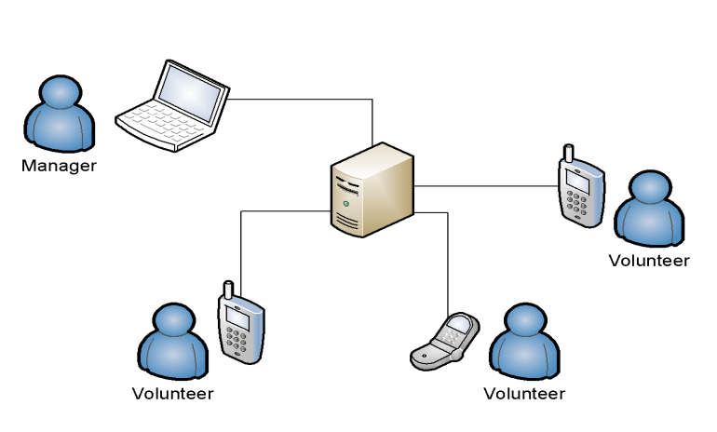
It makes use of the most common communication device; mobile phones. However the system has two subsystems, one is VMS Server application which will be used by Manager for handling crisis and the other one is the VMS client which is also called as Mobile Application, this will be used by Volunteers. This System also interfaces with an external GIS System. GIS System is used for identifying or for searching volunteers.

Constraints and Assumptions
VMS system depends on the following assumptions:
- Citizens should use high end mobile phones with java supportability to get the instructions from the command center
- VMS application should be installed in the user’s mobile at the time of crisis. If they don’t have the application installed already; at least they should be able to get the internet access to get the application from the internet and install it into the mobile phone.
- And also assumed that network coverage and internet is available for the mobile phones in case of crisis and the mobile phone has required features for connecting internet.
The following are some of the constraints of VMS
- The main constraint of Mobile Application is that the application should be installed and the Volunteers should be a registered user to the application.
- And only the authorized Manager can request for help to the volunteers, Authorization will be given at the time of registration by the Managers

Functional Requirements

Actors
Volunteer: Part of general public who wants to help crisis affected people, contains many different class of people such as young, old, educated, uneducated, poor, reach etc. They are the workforce or the resource in VMS point of view.
Manager: Authorized people of help organization, and specialized in specific crises. They are responsible to coordinate between different volunteers, staff members and higher management to address the crisis.

Use Case Diagram

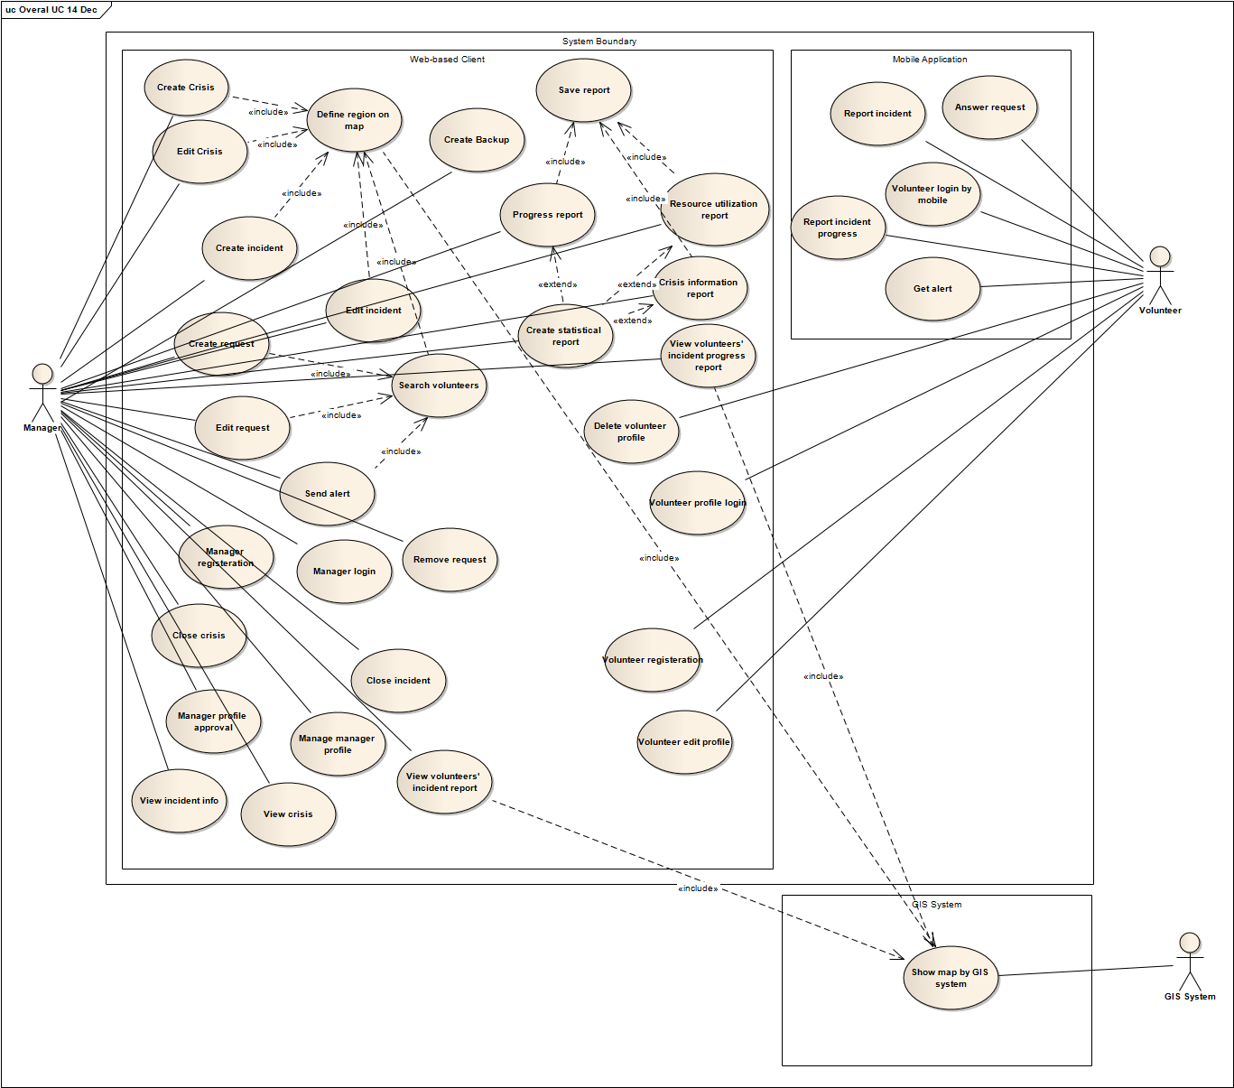

Use Cases
Use cases are segregated among the features of VMS system (please refer vision document for features details). The following table shows the features and supping use cases.
Number | Feature name | Use case Id
1 | Registration and membership | UC 09, UC 10, UC 11, UC 12, UC 22, UC 25.
2 | Profile Management | UC 13, UC 25, UC 28, UC 29
3 | Resource Management | UC 06, UC 07, UC 08, UC 16,UC 18, UC 23, UC 27
4 | Incident Management | UC 01, UC 02, UC 03, UC 04, UC 05, UC 06, UC 07, UC 08, UC 15, UC 16, UC 17,UC 18, UC 19, UC 20, UC 21, UC 23, UC 24, UC 26, UC 27, UC 35, UC 30, UC 31, UC32, UC33
5 | Information Gathering
5 | Reporting new incidents | UC 15
5 | Reporting the statues of the existing incidents | UC 17
6 | Communication | UC 08, UC 15, UC 19, UC 23, UC 27
6 | Warning the user | UC 16
6 | Send Request for the help | UC 06, UC 07
7 | Log Analysis and Backup | UC 14, UC 30, UC 31, UC32, UC33, UC 34

Create crisis (use-case)

Use Case Name | Create crisis
Description | Manager defines a new crisis in the system.
Actors | Manager
Identifier | UC 01
Pre-conditions
- Manager should be logged in.
- There is no active crisis in the system.
- Crisis Management main page is opened
Post-conditions
- A new crisis is created. System is ready to work on it.
- The data and actions are logged in the system.
R01-1 Main Path
- Manager selects “Create new crisis” menu
- System shows new Crisis Information Page containing the map.
- Manager fills the form and saves:
Selects type of the crisis from a list.
Defines the crisis and recourse area on the map refer to Define region on map use-case
Enters information in message box
Presses save button
- System validates the data and saves the information and navigates to Crisis Management main page.
Alternate Paths
R01-2
In step 4, the system finds that some data are invalid and shows a message to Manager about the problems in data. Workflow goes to step 3.
R01-3
In step 3, Manager presses ‘Cancel’ button. Then system ignores all data entered and navigates to Crisis Management main page.
Non-Functional

Issues
Only one crisis can exist at a given time.

Edit crisis (use-case)

Use Case Name | Edit crisis
Description | Manager modifies any information of a previously created crisis that is active.
Actors | Manager
Identifier | UC 02
Pre-conditions
- Manager should be logged in
- There is an active crisis in the system.
- Crisis Management main page is opened
Post-conditions
- Crisis information updated
- The data and actions are logged in the system.
R02-1 Main Path
- Manager selects the active crisis from the list and presses “Edit crisis” menu
- System shows the Crisis Information Page with the map.
- Manager edits the crisis information and saves:
Changes type of the crisis from a list (with Earthquake, Epidemic, and Fire).
Redefines the crisis and resources area on the map refer to Define region on map use-case
Edits information message
Presses save button
- System validates the data in the form, saves the information, navigates to Crisis Management main page and shows a short notification of successful update.
Alternate Paths
R02-2
In step 4, The system finds that some data are invalid and shows a message to Manager about the problems in data then workflow continues from step 3
R02-3
In step 3, Manager presses Cancel button. Then system ignores all data entered and navigates to Crisis Management main page
Non-Functional
Issues

Close Crisis (use-case)
Use Case Name | Close Crisis
Description | All incidents are closed and Manager closes the active crisis.
Actors | Manager
Identifier | UC 03
Pre-conditions
- Manager should be logged in.
- All incidents are closed
- There is an active crisis in the system.
- Crisis Management main page is opened
Post-conditions
- Crisis is archived
- The data and actions are logged in the system.
R03-1 Main Path
- Manager selects the active crisis from the list of crisis and presses “Close crisis” button
- System asks for confirmation.
- Manager presses OK button.
- System changes the crisis’ state.
Alternate paths
R03-2
In step 3, Manager presses Cancel button. Then system ignores any change.
Non-Functional
Issues

Create Incident (use-case)
Use Case Name | Create Incident
Description | Manager defines a new incident in the system including resources needed for that incident.
Actors | Manager
Identifier | UC 04
Pre-conditions
- Manager should be logged in.
- There is an active crisis in the system
- Crisis Management main page is opened
Post-conditions
- A new incident with needed resources for that is defined and crisis map is updated
- The data and actions are logged in the system.
R04-1 Main Path
- Manager selects “Create incident” menu
- System shows New Incident Page containing a map
- Manager fills the form:
Defines the incident and resources area on the map refer to Define region on map use-case
Selects the type of the incident from the incident type list(with predefined values as building collapsed etc)
Enters explanation of incident
Selects the severity (Critical/Serious/Normal/Moderate/Minor)
Selects the priority(High/Medium/Low)
Defines the resources need list by entering type of need, amount and units for that need.
Presses the OK button
- System validates the data in the form, saves the information, navigates to Crisis Management main page and updates the crisis map.
Alternate paths
R04-2
In step 4, the system finds that some data are invalid and shows a message to Manager about the problems in data. Workflow goes to step 3.
R04-3
In step 3, Manager selects Cancel button. Then system ignores all data entered and navigates to Crisis Management main page
Non-Functional
Issues

Edit Incident (use-case)
Use Case Name | Edit Incident
Description | Manager edits the information of an active incident.
Actors | Manager
Identifier | UC 05
Pre-conditions
- Manager is logged in.
- There is an active incident in the system.
- Crisis Management main page is opened
Post-conditions
- Information of the active incident is updated.
- The data and actions are logged in the system.
R05-1 Main Path
- Manager selects the incident from the incidents list
- System shows information and options for the incident
- Manager selects “Edit incident” menu
- System shows Incident Information page.
- Manager changes incident information and saves:
Changes type of the incident
Changes severity by selecting it from a list.
Changes priority by selecting it from a list.
Redefines the incident and resources area on the map refer to Define region on map use-case
Removes unnecessary needs from the resources need list
Adds new needs to the resources need list
Modifies the list of resource need list by entering type of need, amount and units.
Presses the Save button
- System validates the data in the form, saves the information, navigates to Crisis Management main page and shows a short notification of successful update.
Alternate paths
R05-2
In Step 6, The system finds that some data are invalid and shows a message to Manager about the problems in data. Workflow continues from step 5
R05-3
In step 5, Manager presses Cancel button. System ignores all changes and navigates to Crisis Management main page.
Non-Functional
Issues

Create Request (use-case)

Use Case Name | Create Request
Description | Manager creates and sends a request related to an active incident.
Actors | Manager
Identifier | UC 06
Pre-conditions
- There is an active incident
- Crisis Management main page is opened
Post-conditions
- Automatic request sending is started.
- The data and actions are logged in the system.
R06-1 Main Path
- Manager finds volunteer refer to Search Volunteers use-case
And selects the incident from the list of incidents
- System shows information and options for the incident
- Manager selects “Create Request” option
- System shows Create Request Page
- Manager fills the form and Sends request:
Enters a message to the volunteers
Presses ‘Send Request’ button.
- System saves and sends the Manager’s massage with the incident need list, incident location to the Mobile Application and navigates to Crisis Management main page.
Alternate paths
R06-2
In step 5, Manager presses the Cancel button. Then system ignores this dialog and returns to Crisis Management main page.
Non-Functional
Issues

Edit Request (use-case)
Use Case Name | Edit Request
Description | Manager will change the content of a request of an incident.
Actors | Manager
Identifier | UC 07
Pre-conditions
- There is an active incident and is active request for that incident
- Crisis Management main page is open
Post-conditions
- System updates the request for volunteers.
- The data and actions are logged in the system.
R07-1 Main Path
- Manager finds volunteer refer to Search Volunteers use-case and selects the incident from the list of incidents
- System shows information and options for the incident
- Manager selects request and presses “Edit Request” menu
- System shows Edit Request page
- Manager edits the information, saves and sends request:
Edits a message for volunteers
Presses ‘Send Request’ button.
- System saves and sends the Manager’s massage with the incident need list, incident location to the Mobile Application and navigates to Crisis Management main page
Alternate paths
R07-2
In step 5, Manager presses the Cancel button. Then system ignores the change and returns to Crisis Management main page.
Non-Functional
Issues

Answer Request (use-case)
Use Case Name | Answer Request
Description | Volunteer receives a request on Mobile Application and responds to it.
Actors | Volunteer
Identifier | UC 08
Pre-conditions
- Volunteer is logged in to the system by Mobile Application
- Volunteer has a new request
- Mobile Application main page is opened
Post-conditions
- System updates resources need list
- The data and actions are logged in the system.
R08-1 Main Path
- Volunteer selects the request
- Mobile Application shows Request information
Shows Manager’s message
Shows location of incident
Shows need list (type, amount and unit).
- Volunteer reads the request message with need list.
Volunteer enters the amount he/she can provide by filling amount row and presses the Accept button.
- System registers the data, saves it and recalculates the amount of needs according to entered resources.
Alternate paths
R08-2
In step 3, Volunteer presses Reject button. Then system updates his/her request as rejected in the system and navigates to Mobile Application main page.
R08-3
Volunteer doesn’t take any action on that request neither accepts nor rejects. System waits for 10 minutes (from the time of sending the request) and then assumes the request as rejected.
Non-Functional
Issues

Manager login (use-case)
Use Case Name | Manager login
Description | Manager logins to the system.
Actors | Manager
Identifier | UC 09
Pre Conditions
- Manager is registered in the system.
- Crisis Management login page is opened
Post Conditions
- Manager is logged in the system
- The login of the Manager is logged in the system.
R09-1 Main Path
- Manager fills the login page:
Enters username and password
Selects ‘Manager’ as user type from the list (Manager/Volunteer)
Presses Login button
- System authenticates the Manager and navigates to Crisis Management main page.
Alternate paths
R09-2
In the step 2, system warns about incorrect username and/or password. Workflow goes to step 1.
R09-3
In the step 2, system warns that Manager with the same username is already logged in.
Non-Functional
Issues

Volunteer login by mobile (use-case)
Use Case Name | Volunteer login by mobile
Description | Volunteer logins using Mobile Application.
Actors | Volunteer
Identifier | UC 10
Pre-condition
- Volunteer has already been registered.
- Volunteer is not logged in
- Mobile Application login page is opened
Post-conditions
- Volunteer is logged in the system by the Mobile Application
- The login of the Volunteer is logged in the system.
R10-1 Main Path
- Volunteer fills login form
Enters the username
Enters the password
Presses login button
- System authenticates the Volunteer and opens the starting page of Mobile Application
Alternate paths
R10-2
In the step 2, application warns about incorrect username and/or password. Workflow goes to step 1
R10-3
In the step 2, application warns that a Volunteer with the same username is already logged in. Workflow goes to step 1.
R10-4
In the step 1, Volunteer presses Exit button
System exits from the Mobile Application, workflow ends.
Non-Functional
Issues

Manager Registration (use-case)
Use Case Name | Manager Registration
Description | Manager registers using our web portal.
Actors | Manager
Identifier | UC 11
Pre-conditions
- Manager has not been registered before.
- Crisis Management Login page is opened
Post-conditions
- Registration is completed and waits for approval.
- The registration of the new Manager is logged in the system.
R11-1 Main Path
- Manager selects ‘Manager’ as user type (Manager/Volunteer) and selects “Register” menu
- System navigates to Managers Registration page
- Manager enters required information and Register:
Enters personal information.
Selects the incident types he/she is good at managing. (fire, bombing …)
Selects username and password.
Presses Register button
- System verifies information, saves information, navigates to login page, shows massage about successful registration and sends data for approval.
Alternate paths
R11-2
In the step 4, system warns Manager about incorrect and missing data. Workflow goes to step 3.
R11-3
From step 3, Manager selects Cancel button. Then system ignores all data entered and navigates to Login page.
Non-Functional
Issues

Volunteer Registration (use-case)
Use Case Name | Volunteer Registration
Description | Volunteer registers by web page
Actors | Volunteer
Identifier | UC 12
Pre-conditions
- Crisis Management Login page is opened
Post-conditions
- Volunteer is registered and automatically logged into the system.
- The registration of the new Volunteer is logged in the system.
R12-1 Main Path
- Volunteer selects ‘Volunteer’ as user type (Manager/Volunteer) and selects “Register” menu from Login page
- System shows Volunteers Registration page
- Volunteer enters required information and registers
Name, last name
Age, gender, address
phone, job, email address
Height, weight
Education
Special training
Any health problem
Country
City
Selects username and password
Presses Register button
- System registers new Volunteer and opens Volunteer’s profile page
Alternate paths
R12-2
In the step 4, application warns about incorrect data, incorrect username and/or password. Workflow goes to step 3
R12-3
In step 3, volunteer selects Cancel button. Then system ignores all data entered and navigates to Login page.
Non-Functional
Issues

Volunteer edits profile (use-case)
Use Case Name | Volunteer edits profile
Description | Volunteer edits personal information he/she has.
Actors | Volunteer
Identifier | UC 13
Pre-conditions
- Volunteer is logged in the system by web application
- Volunteer’s profile page is opened
Post-conditions
- Volunteer’s profile information is updated.
- The data and actions are logged in the system.
R13-1 Main Path
- Volunteer changes any one of them and saves:
Name, last name
Age, gender, address
phone, job, email address
Height, weight
Education
Special training
Any health problem
Country
City
Password
Presses Save button
- System saves the changes, shows message for successful save.
Alternate paths
R13-2
In step 1, Volunteer selects log off menu. System discards all changes, logs out Volunteers from the system and navigates to Crisis Management Login page
Non-Functional
Issues

Create Statistical Report (use-case)
Use Case Name | Create Statistical Report
Description | Manager generates the statistical reports from Managerial purpose on crisis
Actors | Manager
Identifier | UC 14
Pre-conditions
- Manager is logged in.
- Crisis Management main page is opened
Post-conditions
- Manager will generate statistical report.
- The data and actions are logged in the system.
R14-1 Main Path
- Manager selects “Statistical Report” menu
- System shows the Statistical Report page.
- Manager selects
Crisis from the crisis list
Presses the Crisis information report button.
- System generates the Crisis information report refer to Crisis information report use case
Alternate paths
R14-2
In step 3, Manager presses Cancel button. System navigates to Crisis Management main page.
R14-3
In step 3, Manager selects
Crisis from the crisis list
Incident from the incident list
Presses the Progress report button.
System generates the Progress report refers to Progress report use case.
R14-4
In step 3, Manager selects
Crisis from the crisis list
Presses the Resource Utilization report button.
System generates the Resource Utilization report refers to Resource Utilization report use case.
Non-Functional
Issues

Report Incident (use-case)
Use Case Name | Report Incident
Description | Volunteers reports about incident through Mobile Application
Actors | Volunteer
Identifier | UC 15
Pre-conditions
- Volunteer is logged in to system by Mobile Application
- Mobile Application main page is opened
Post-conditions
- Incident report is saved in the system
- The data and actions are logged in the system.
R15-1 Main Path
- Volunteer selects 'Report Incident' menu
- Mobile Application shows ‘Report Incident' page
- Volunteer fills the report form:
Location of Incident in text
Type of incident
Enters message for Manager
Presses 'Send' button
- Mobile Application validates the data entered, sends the report to the system and navigates to Mobile Application main page.
Alternate paths
R15-2
In step 3, Volunteer selects 'Cancel' button. Mobile Application discards all information and navigates to Mobile Application main page
R15-3
In step 4, Mobile Application verifies missing data and inform volunteer. Flows go to step 3
R15-4
In Step 3, Volunteer presses 'Photo' button
Mobile Application navigates to Picture page.
Volunteer presses 'Take Picture' button
Mobile Application takes picture, adds to the volunteer’s report and automatically returns to Report Incident page. Flows go to step 3.
R15-5
In Step 3, Volunteer presses 'Video' button
Mobile Application navigates to ‘Video’ page.
Volunteer presses and holds Record button
Mobile Application records the video
Volunteer releases the pressed button
Mobile Application stops the recording, adds the video to the volunteer’s report and automatically returns to Report Incident page. Flows go to step 3.
Non-Functional
Issues

Send Alert (use-case)
Use Case Name | Send Alert
Description | Manager sends alert to some volunteers based on their location or other information.
Actors | Manager
Identifier | UC 16
Pre-conditions
- Manager is logged in.
- Crisis Management main page is opened
Post-conditions
- Alert sent to a list of volunteers.
- The data and actions are logged in the system.
R16-1 Main Path
- Manager finds volunteer refer to Search Volunteers use-case
- System displays volunteers list
- Manager selects a subset of volunteers from the list and presses 'Send alert' menu
- System shows the sending alert form
- Manager enters the message for the volunteers and presses Send button
- System saves message and send alert to the Mobile Application
Alternate paths
R16-2
In step 5, Manager presses Cancel button. System ignores all changes and navigates to Crisis Management main page.
Non-Functional
Issues

Report Incident Progress
Use Case Name | Report Incident Progress
Description | Volunteers that are assigned to a particular incident will have an option to send progress report.
Actors | Volunteer
Identifier | UC 17
Pre-conditions
- Volunteer should be logged in to the system.
- Volunteer is assigned to an incident.
- Mobile Application main page is opened
Post-conditions
- Report will be sent to the system.
- The data and actions are logged in the system.
R17-1 Main Path
- Volunteer selects “Repot progress” menu
- Mobile Application displays Report Progress page.
- Volunteer fills the report form:
Types a number which shows the percentage of tasks done upon requested tasks
Enters message for Manager
Presses 'Send' button
- Mobile Application validates the data entered, sends the report to the system and navigates to Mobile Application main page.
Alternate paths
R17-2
In step 3, Volunteer selects 'Cancel' button. Mobile Application discards all information and navigates to Mobile Application main page
R17-3
In step 4, Mobile Application verifies missing data and inform volunteer. Flows go to step 3
R17-4
In Step 3, Volunteer presses 'Photo' button
Mobile Application navigates to Picture page.
Volunteer presses 'Take Picture' button
Mobile Application takes picture, adds to the volunteer’s report and automatically returns to Report Incident page. Flows go to step 3.
R17-5
In Step 3, Volunteer presses 'Video' button
Mobile Application navigates to ‘Video’ page.
Volunteer presses and holds Record button
Mobile Application records the video
Volunteer releases the pressed button
Mobile Application stops the recording, adds the video to the volunteer’s report and automatically returns to Report Incident page. Flows go to step 3.
Non-Functional
Issues
- The status information sent by the volunteer is just a report for information of Manager.

Search Volunteers (use-case)
Use Case Name | Search Volunteers
Description | Manager searches volunteers according to their profile information and location.
Actors | Manager
Identifier | UC 18
Pre-conditions
- Manager should be logged in.
- Crisis Management main page is opened
Post-conditions
- System generates a list of volunteers selected
R18-1 Main Path
- Manager searches volunteers
defines the area of resources on the map refer to Define region on map use-case
enters key information to search box
presses Search button
- System shows the matched volunteers list and their locations
Alternate paths
Non-Functional
Issues

View Volunteers’ Incident Report (use-case)

Use Case Name | View Volunteers’ Incident Report
Description | Manager gets the reports from volunteers that will be used for creating or updating incidents
Actors | Manager
Identifier | UC 19
Pre-conditions
- Manager is logged in.
- Crisis Management main page is opened
Post-conditions
- Manager will view reports by volunteers’ side.
R19-1 Main Path
- Manager selects “Incident Report” menu
- System shows the Incident Report page containing the list of volunteer’s reports.
- Manager selects report from report list
- System shows the report information
Shows location on the map using Show map use-case of GIS system
Volunteers message
Incident picture
Incident Video
Alternate paths
R19-2
In step 3, Manager presses Cancel button. System navigates to Crisis Management main page.
Non-Functional
Issues

View Incident Information (use-case)
Use Case Name | View Incident Information
Description | Manager views the incident details.
Actors | Manager
Identifier | UC 20
Pre-conditions
- Manager is logged in.
- There is an incident in the system.
- Crisis Management main page is opened.
Post-conditions
- View the detailed view of incident.
R20-1 Main Path
- Manager selects the Incident from incidents list and presses ‘View Incident’
- System shows Incident view page with the incident details.
List of volunteers assigned
Location
Type of the incident
Need list
Managers message
- Manager Presses Ok Button.
- System navigates to Crisis Management main page
Alternate paths
Non-Functional
Issues

Close Incident (use-case)
Use Case Name | Close Incident
Description | Manager change the state of incident.
Actors | Manager
Identifier | UC 21
Pre-conditions
- Manager is logged in.
- There is an active incident in the system.
- Crisis Management main page is opened.
Post-conditions
- Incident state changed to Closed
- The data and actions are logged in the system.
R21-1 Main Path
- Manager selects the Incident from incidents list and presses ‘Close Incident’
- System asks for confirmation.
- Manager presses Ok button
- System changes the status of incident to ‘closed’.
Alternate paths
R21-2
In step 3, Manager presses Cancel button. System takes no action.
Non-Functional
Issues

Volunteer Profile Login (use-case)
Use Case Name | Volunteer Profile Login
Description | Volunteer logins to his/her profile through web portal.
Actors | Volunteer
Identifier | UC 22
Pre Conditions
- Volunteer is registered in the system.
- Login page is opened.
Post Conditions
Volunteer is logged in the system
The Volunteer login is logged in the system.
R22-1 Main Path
- Volunteer fills the login page:
Enters username and password
Selects ‘Volunteer’ as user type from the list (Manager/Volunteer)
Presses Login button
- System authenticates the Volunteer and navigates to Edit Profile page.
Alternate paths
R22-2
In the step 2, system warns about incorrect username and/or password. Workflow goes to step 3.
R22-3
In the step 2, system warns that volunteer with the same username is already logged in.
Non-Functional
Issues

Get Alert (use-case)
Use Case Name | Get Alert
Description | Volunteer gets alert from the system based on their location or other information.
Actors | Volunteer
Identifier | UC 23
Pre-conditions
- Volunteer is logged in to the system by Mobile Application
- Mobile Application main page is opened
- There is an alert message in Mobile Application
Post-conditions
R23-1 Main Path
- Volunteer selects the alert message
- System shows message information
- Volunteer selects OK button
- System navigates to Mobile Application main page
Alternate paths
R23-2
In step 3, Volunteer presses Delete button. Mobile Application deletes the message and navigates to Mobile Application main page.
Non-Functional
Issues

View Crisis (use-case)
Use Case Name | View Crisis
Description | Manager searches and view a particular crisis.
Actors | Manager
Identifier | UC 24
Pre-conditions
- Manager is logged into the system.
- There is previously created crisis in system
- Crisis Management main page is opened
Post-conditions
R24-1 Main Path
- Manager selects the crisis from the list and presses “View crisis” menu
- System shows all information about the crisis such as incidents, date, type, location on the map
- Manager presses Main page menu
- System navigates to Crisis Management main page.
Non-Functional
Issues

Manager profile approval (use-case)
Use Case Name | Manager profile approval
Description | New Manager registration approval.
Actors | Manager
Identifier | UC 25
Pre-conditions
- Manager is logged in
- New Manager is registered into the system.
- Crisis Management main page is opened
Post-conditions
- New Manager’s profile is approved
- The data and actions are logged in the system.
R25-1 Main Path
- Manager selects New Managers menu
- System shows new registered Managers list
- Manager selects New Manager from the list
- System shows information about the new Manager
- Manager presses approve button
- System changes the status of the New Manager’s profile to approved, shows the message about successful operation and navigates to Crisis Management main page
Alternating Path
R25-2
In step 3 , 5 Manager select Cancel button , control navigates to Crisis Management main page
R25-3
In step 5, Manager rejects the request. System changes status of New Manager’ profile to rejects and navigates to Crisis Management main page.
Non-Functional
Issues

Define region on the map (use-case)
Use Case Name | Define region on the map
Description | This use case helps the Manager to find and mark an area on the map
Actors | Manager
Identifier | UC 26
Pre-conditions
- Manager should be logged in
- Manager should be faced with a page containing map control
Post-conditions
- A location/region is defined on the map.
R26-1 Main Path
- Manager enters the name of a location in the Search Map field and presses the search button
- System shows the map of the location entered and a pointer at the place on map using use-case Show map of GIS system
- Manager zooms in or zooms out the map to find a suitable view of the location and drags the pointer to change the selected location.
- System preserves the latest location selected by Manager.
Alternate paths
R26-2
In the step 3, system marks an area on the map instead of a location
Manager drags and drops the marker to another place and/or changes the boundary of the marker on the map by mouse
System preserves the latest location changed by the Manager.
Non-Functional
Issues
- Map points to a predefined default location at the beginning if the location/area is a mandatory field

Remove request (use-case)
Use Case Name | Remove request
Description | This use case helps the Manager to remove a request for an active incident from the system.
Actors | Manager
Identifier | UC 27
Pre-conditions
- Manager should be logged in
- There is an active incident in the system for which a request is created.
- Crisis Management main page is opened
Post-conditions
- The request for that incident is removed.
- The data and actions are logged in the system.
R27-1 Main Path
- Manager selects the active incident from the list of incidents
- System shows information and options for the incident
- Manager selects request from the list of requests and selects “Remove request” button
- System asks for confirmation to remove the request from the incident
- Manager presses OK button
- System removes the request from that incident and updates the request’s list of the Mobile Application. The system shows a message in the Mobile Application for the volunteers who accepted the removed request, which inform them about the removal of this request.
Alternate paths
R27-2
In the step 5, Manager presses Cancel button. System ignores any change.
Non-Functional
Issues

Manage Manager Profile (use-case)
Use Case Name | Mange Manager Profile
Description | Manager Edits/Deletes his/her profile.
Actors | Manager
Identifier | UC 28
Pre-conditions
- Manager is logged in the system
- Crisis Management main page is opened
Post-conditions
- Manager profile information is updated or deleted.
- The data and actions are logged in the system.
R28-1 Main Path
- Manager Selects ‘Edit profile’ menu
- System shows the Edit profile Page.
- Manager changes any one of his/her information and saves:
Changes personal information.
Selects the incident types he/she is good at managing. (fire, bombing …)
Selects password.
Presses Save button
- System saves the changes and shows message for successful save.
Alternate paths
R28-2
In step 3 Manager selects cancel menu. System discards all changes and navigates to Crisis Management page
R28-3
In step 3, Manager selects ‘Delete’ button
System asks for confirmation
Manager confirms it by pressing ‘Yes’ button
System log out the Manager.
R28-4
In step 3, Manager selects ‘Delete’ button
System asks for confirmation
Manager confirms it by pressing ‘No’ button
System returns to Edit profile page.
Non-Functional
Issues

Delete Volunteer Profile (use-case)
Use Case Name | Delete Volunteer profile
Description | Volunteer deletes his or her profile
Actors | Volunteer
Identifier | UC 29
Pre-conditions
- Volunteer is logged in the system by web application
- Volunteer’s Edit profile page is opened
Post-conditions
- Volunteer’s profile is deleted from the system.
- The data and actions are logged in the system.
R29-1 Main Path
- Volunteer select ‘Delete’ button
- System asks for confirmation
- Volunteer confirms it by pressing ‘Yes’ button
- System deletes the profile from system and log out the Volunteer.
Alternate paths
R29-2
In step 1 and 3, Volunteer selects log off menu. System discards all changes and log out
R29-3
In step 3, Volunteer selects No button then system takes no action and shows Edit profile page
Non-Functional
Issues

Crisis information Report (use-case)
Use Case Name | Crisis information Report
Description | Manager can create crisis information report
Actors | Manager
Identifier | UC 30
Pre-conditions
- Manager is logged in the system
Post-conditions
- Crisis information report is created
R30-1 Main Path
- System shows Crisis information report page containing
Crisis name
Location
List of incident for that crisis
Number of volunteers assigned to each incident
Start and end date for each incident
- Manager presses Save button
- System saves the report refers to Save Report use case
Alternate paths
R30-2
In step 2 , Manager press ‘Back’ button
System navigates to Statistical Report page
Non-Functional
Issues

Progress Report (use-case)
Use Case Name | Progress Report
Description | Manager can create Progress report
Actors | Manager
Identifier | UC 31
Pre-conditions
- Manager is logged in the system
Post-conditions
- Progress report is created
R31-1 Main Path
- System shows Progress report page containing
Crisis name
Incident name
Line Chart showing the progress the incident through time
- Manager presses Save button
- System saves the report refers to Save Report use case
Alternate paths
R31-2
In step 2 , Manager press ‘Back’ button
System navigates to Statistical Report page
Non-Functional
Issues

Resource Utilization report (use-case)
Use Case Name | Resource Utilization report
Description | Manager can create Resource utilization chart for any crisis report
Actors | Manager
Identifier | UC 32
Pre-conditions
- Manager is logged in the system
Post-conditions
- Resource Utilization report is created
R32-1 Main Path
- System shows Progress report page containing
Crisis name
Pie Chart with the resource utilized for each incident and unused resources
- Manager presses Save button
- System saves the report refers to Save Report use case
Alternate paths
R32-2
In step 2 , Manager press ‘Back’ button
System navigates to Statistical Report page
Non-Functional
Issues

Save Report (use-case)
Use Case Name | Save Report
Description | System saves the report
Actors | Manager
Identifier | UC 33
Pre-conditions
- Manager is logged in the system
- ‘Save file’ Wizard is opened.
Post-conditions
- The report is saved in Manager’s computer
R33-1 Main Path
- Manager chooses the location and file name and presses save button
- System saves the report and disappears the wizard.
Alternate paths
R33-2
In step 2 , Manager press ‘Cancel’ button
System disappears the wizard.
Non-Functional
Issues

Create Backup (use-case)
Use Case Name | Backup
Description | Manager takes backup of the system
Actors | Manager
Identifier | UC 34
Pre-conditions
- Manager is logged in the system.
- Crisis Management main page is opened
Post-conditions
- The action is logged in the system.
- Backup of the system is created
R34-1 Main Path
- Manager Presses ‘Backup’ button
- System asks for confirmation
- Manager confirms it by pressing ‘Ok’ button
- System saves the backup.
Alternate paths
R34-2
In step 3, Manager Presses Cancel button.
System takes no action
Non-Functional
- It is used for maintainability of the system
Issues

View Volunteer Incident Progress report (use-case)
Use Case Name | View Volunteer Incident Progress report
Description | Manager gets the progress reports from volunteers that will be used to updating incidents
Actors | Manager
Identifier | UC 35
Pre-conditions
- Manager is logged in.
- Crisis Management main page is opened
Post-conditions
- The actions are logged in the system
R35-1 Main Path
- Manager selects “Incident Progress Report” menu
- System shows the Incident Progress Report page containing the list of volunteer’s reports.
- Manager selects report from report list
- System shows the report information
Shows location on the map using Show map use-case of GIS system
Volunteers message
Progress information
Incident picture
Incident Video
Alternate paths
R35-2
In step 3, Manager presses Cancel button. System navigates to Crisis Management main page.
Non-Functional
Issues

Activity Diagrams
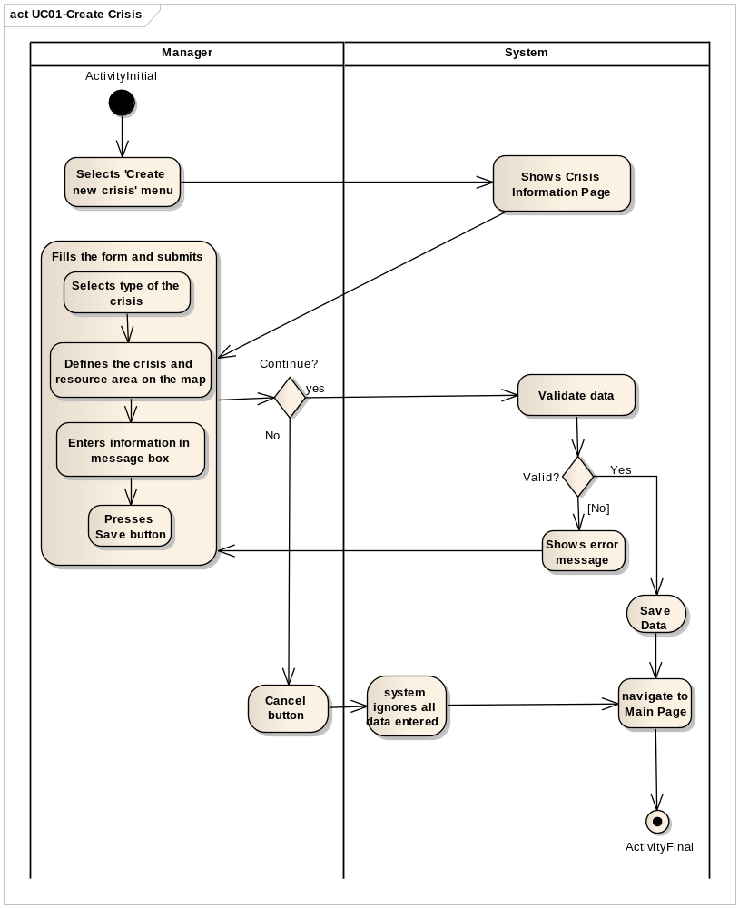
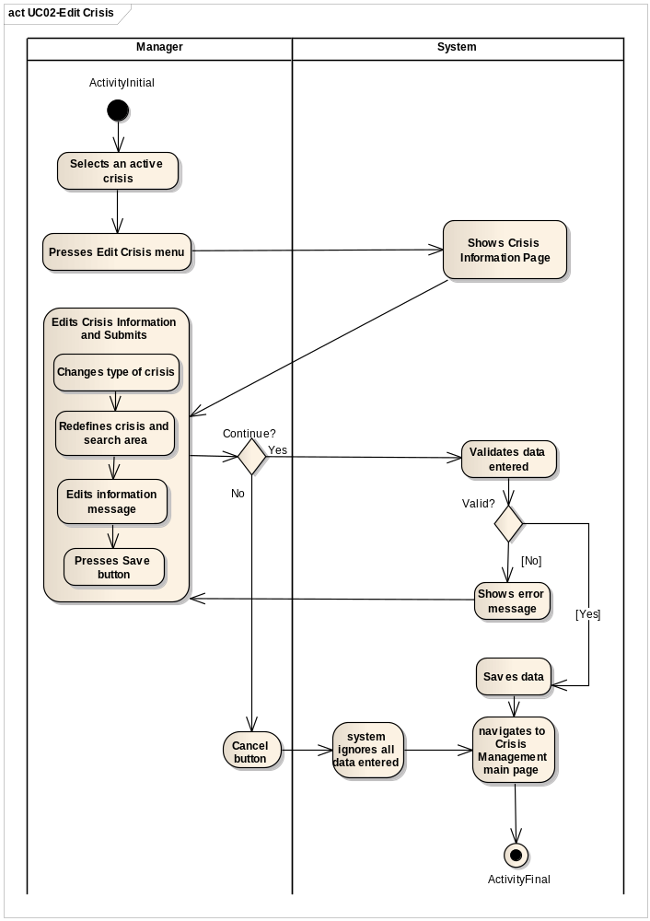
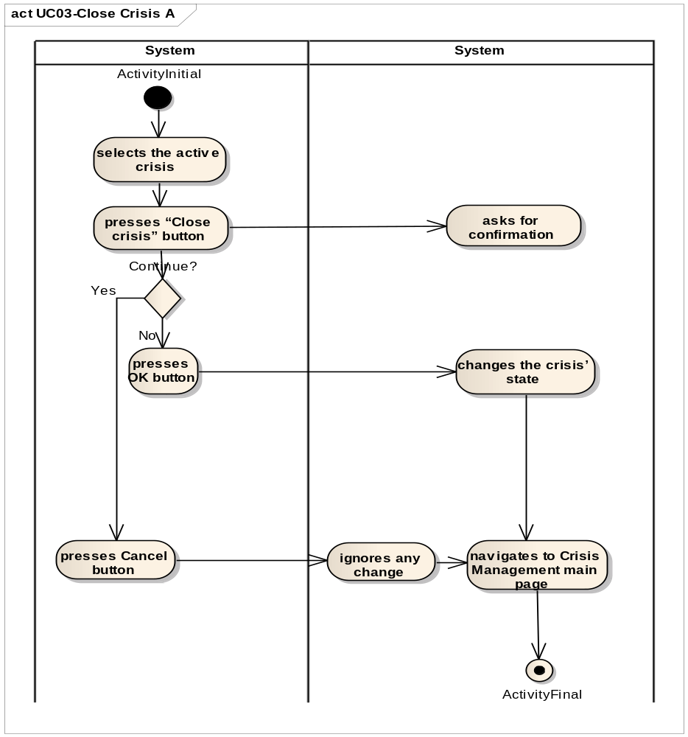
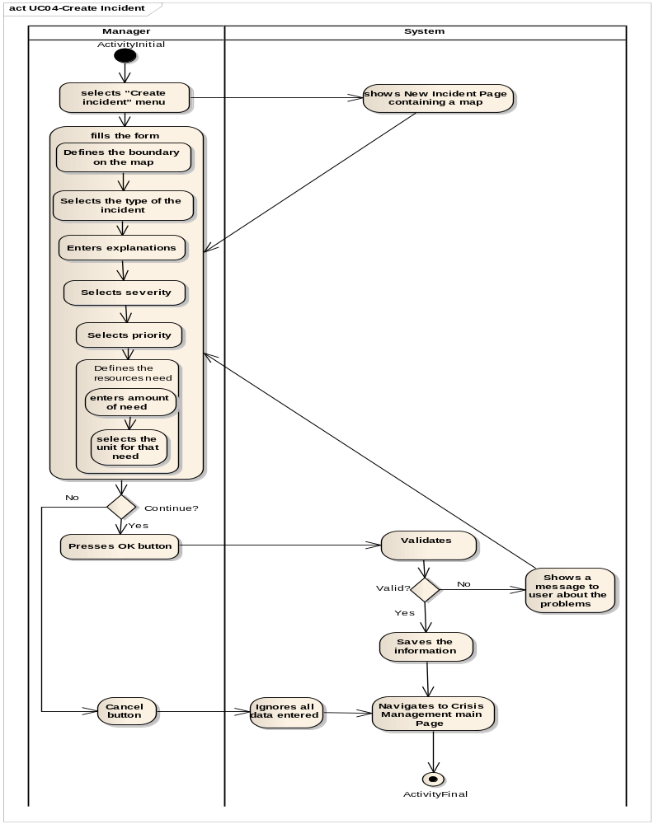
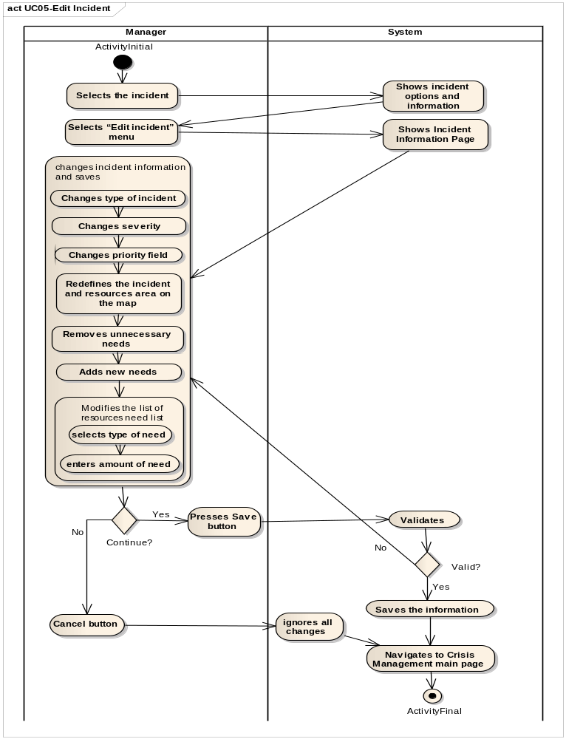
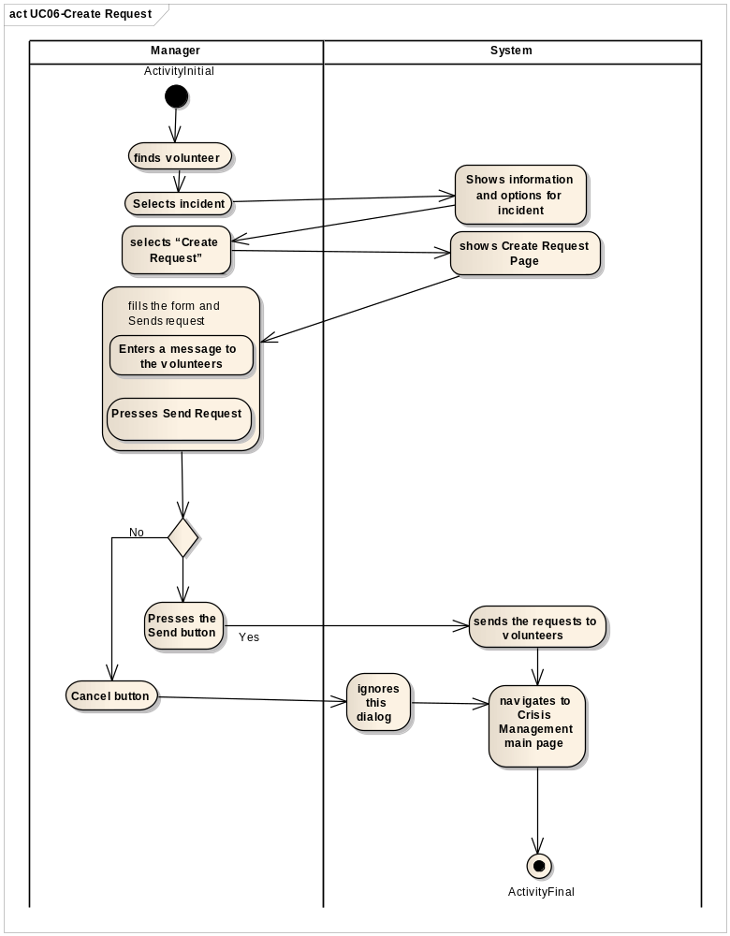

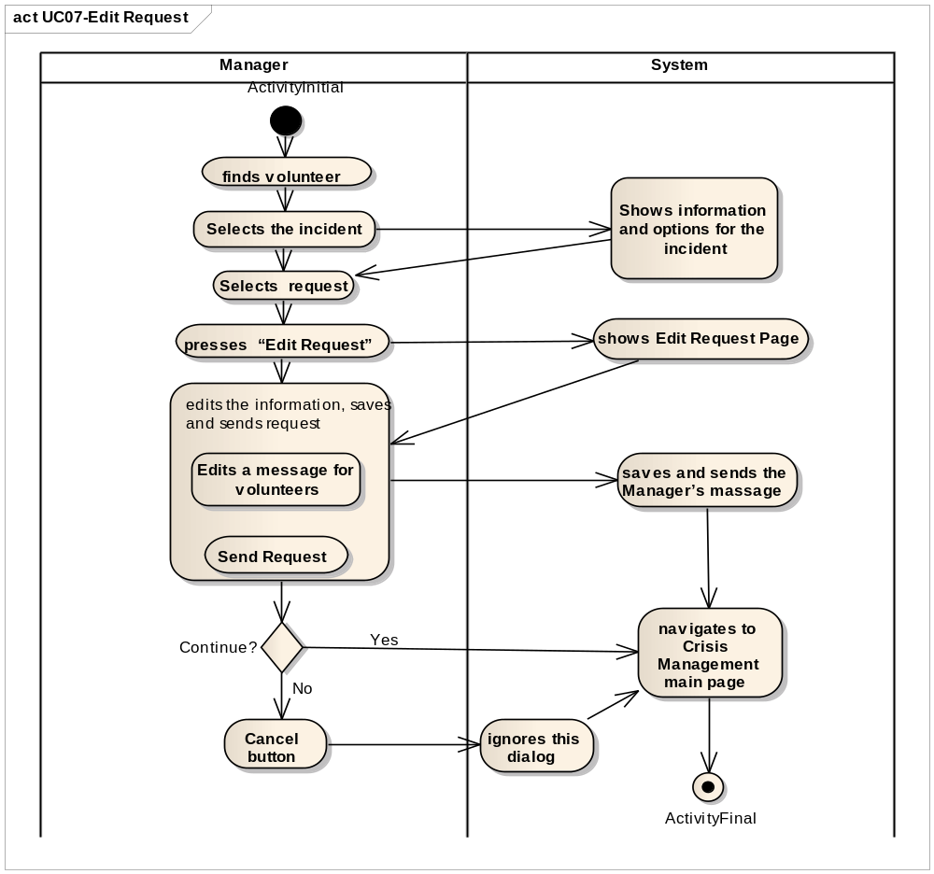
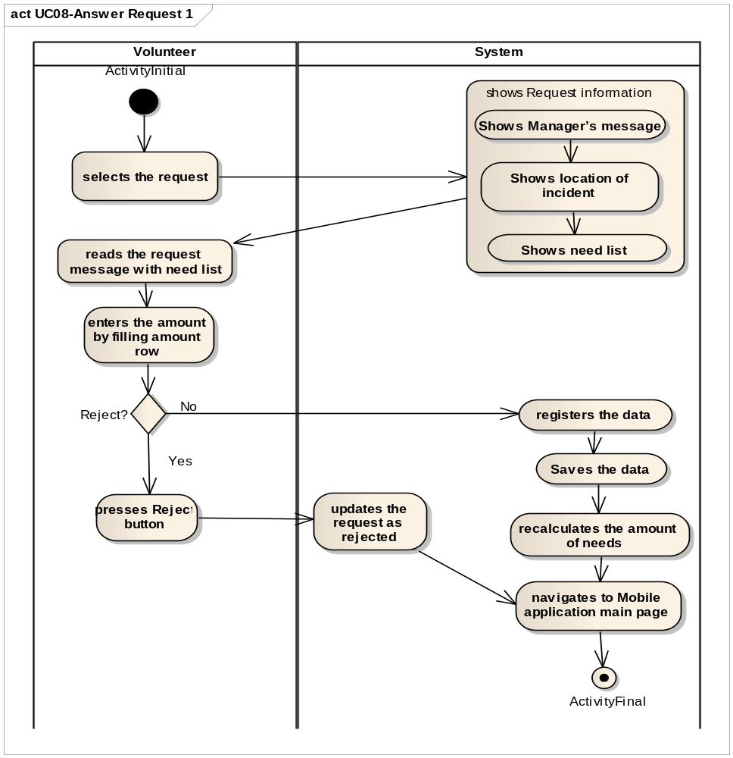
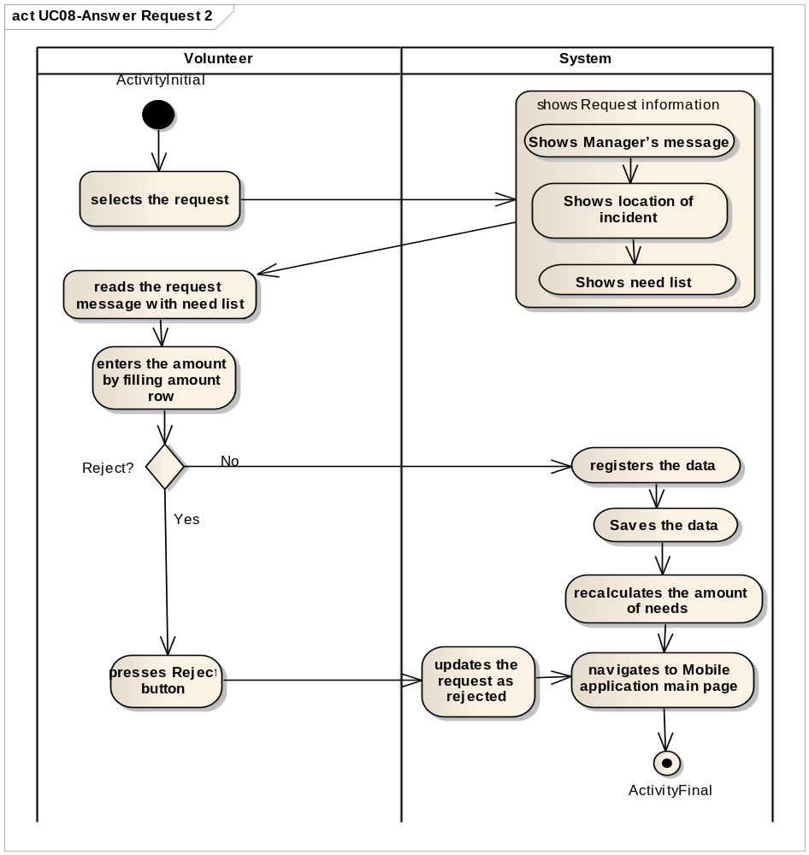
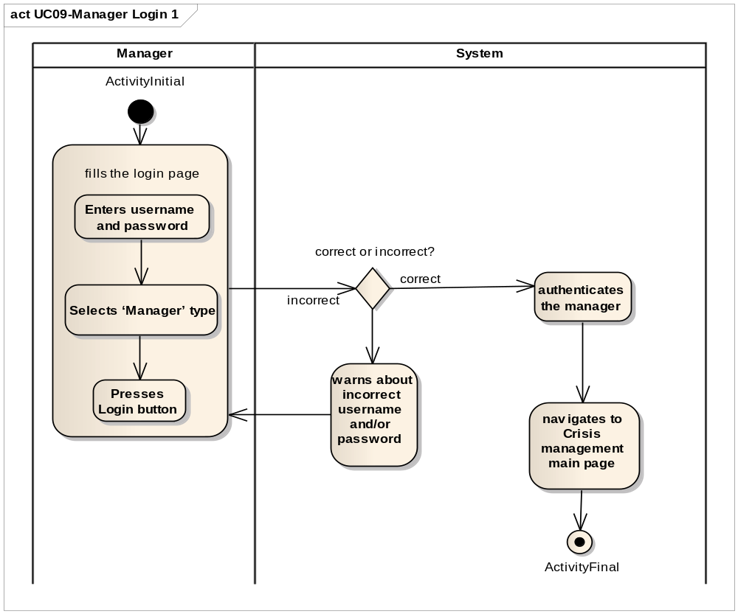
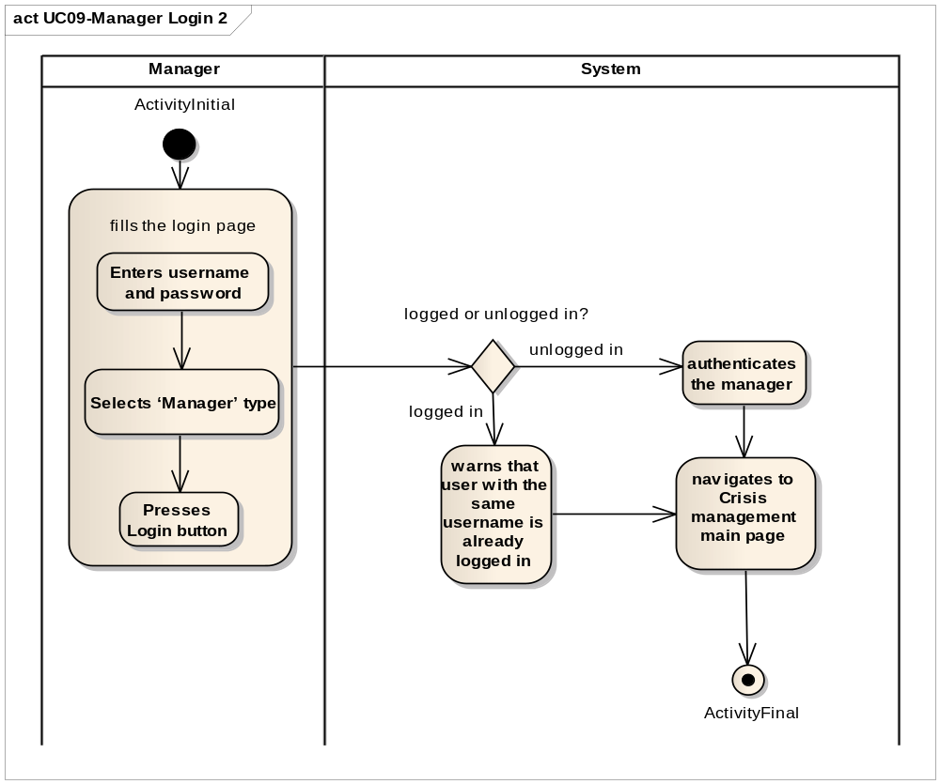
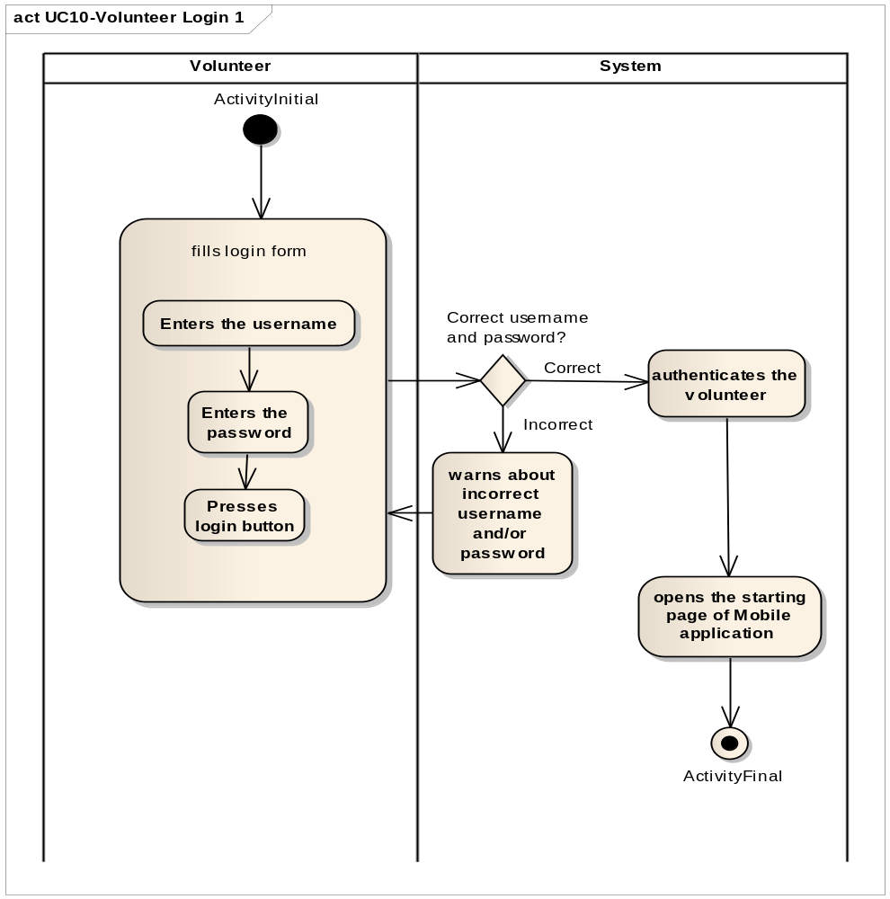
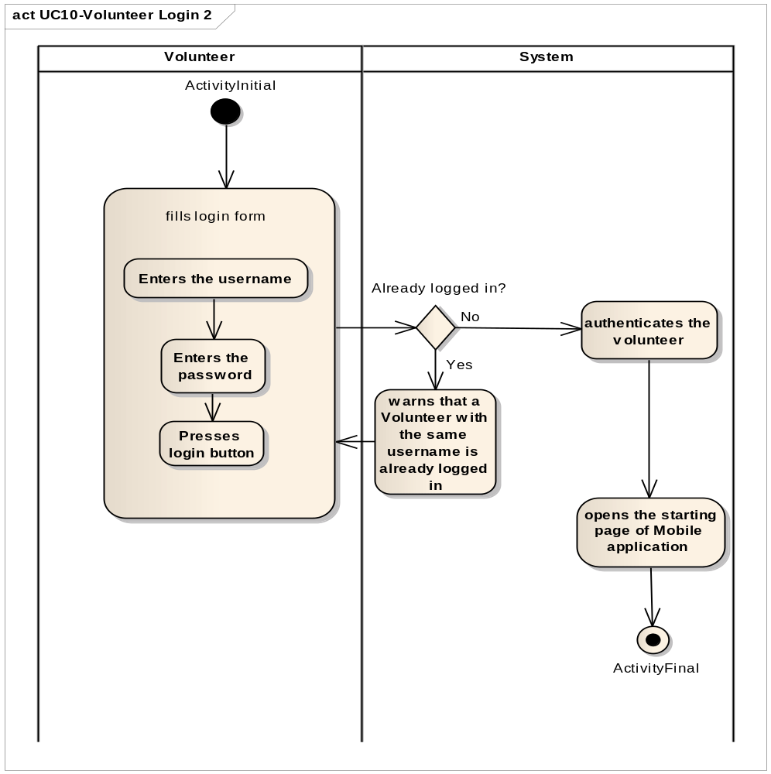
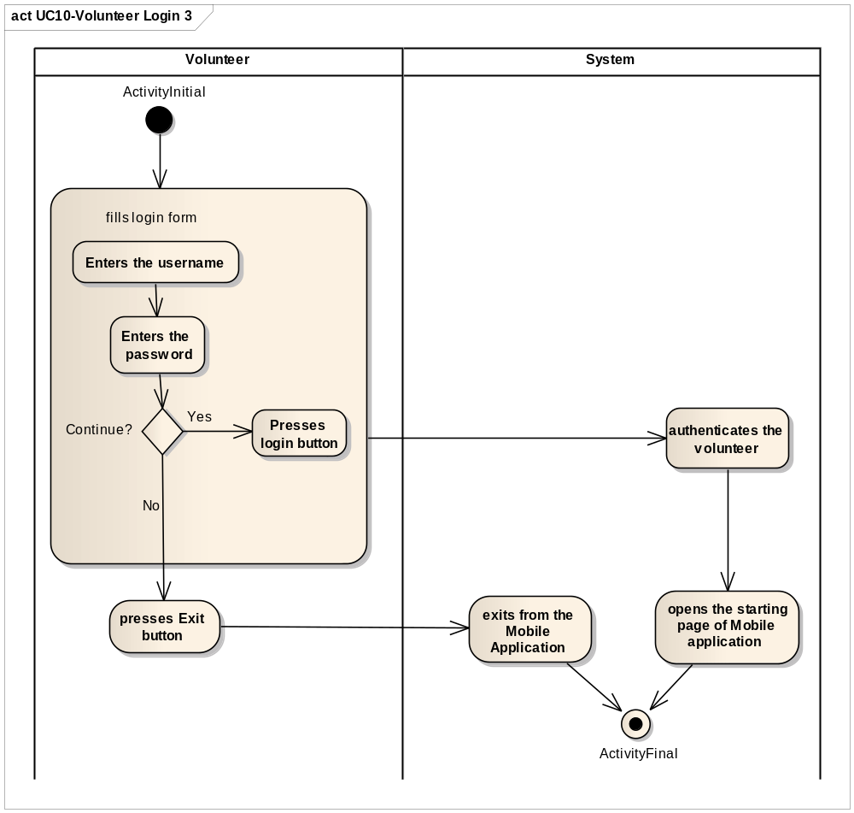
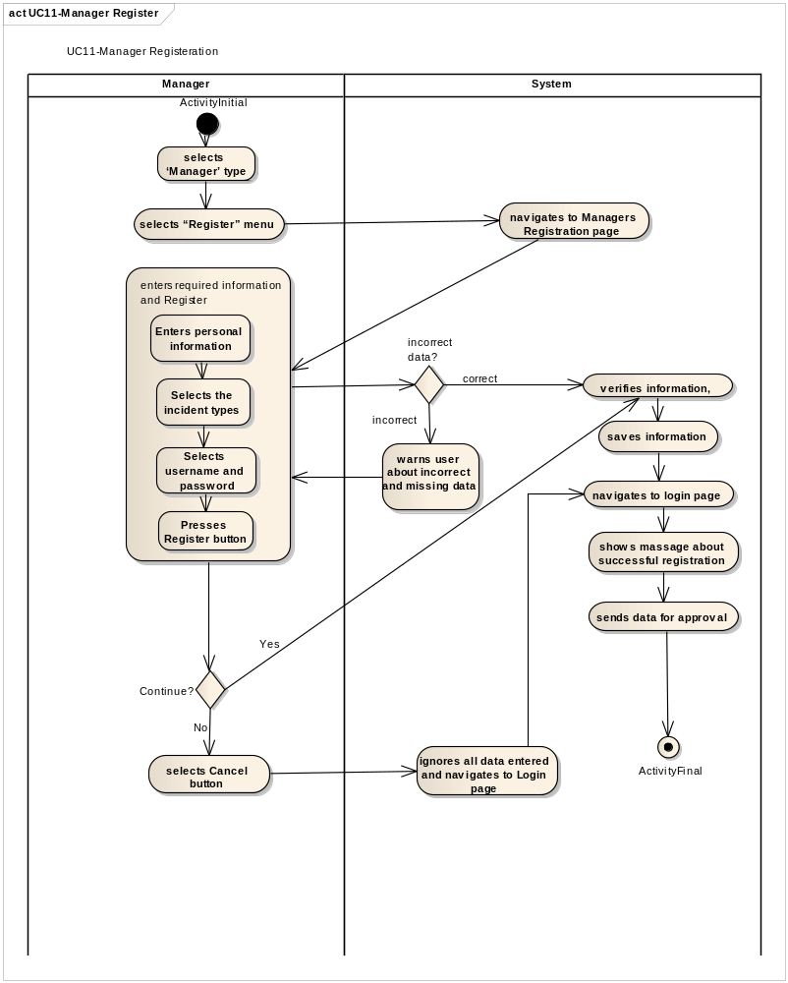
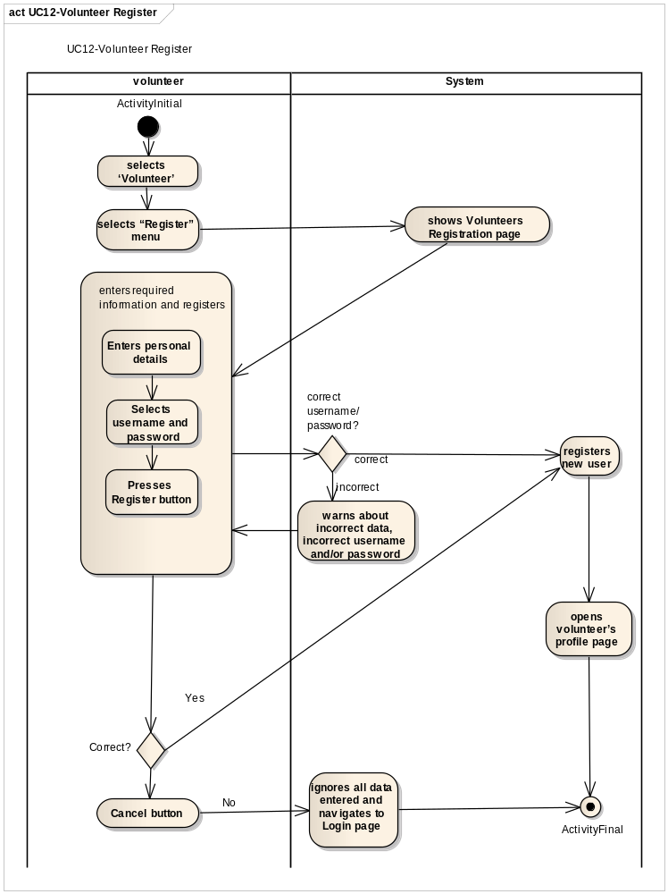
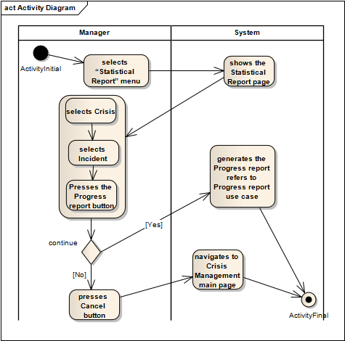
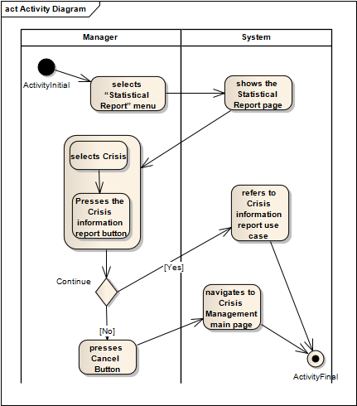
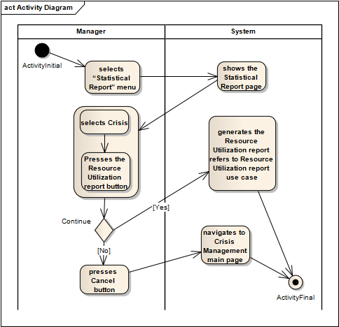
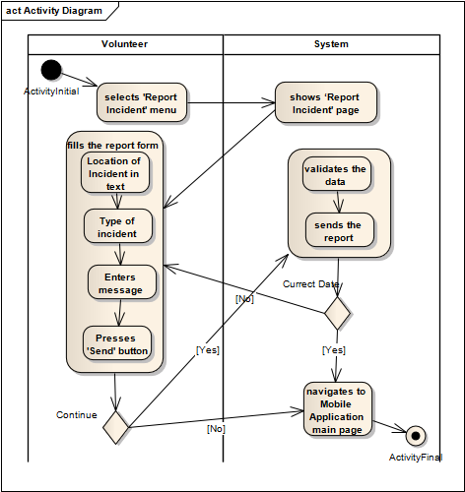

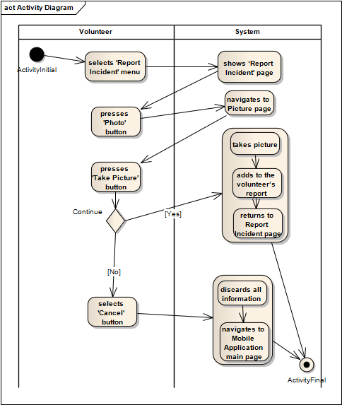
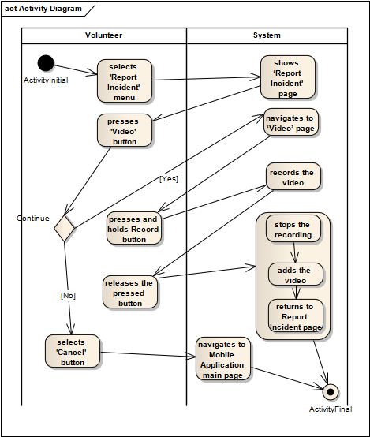
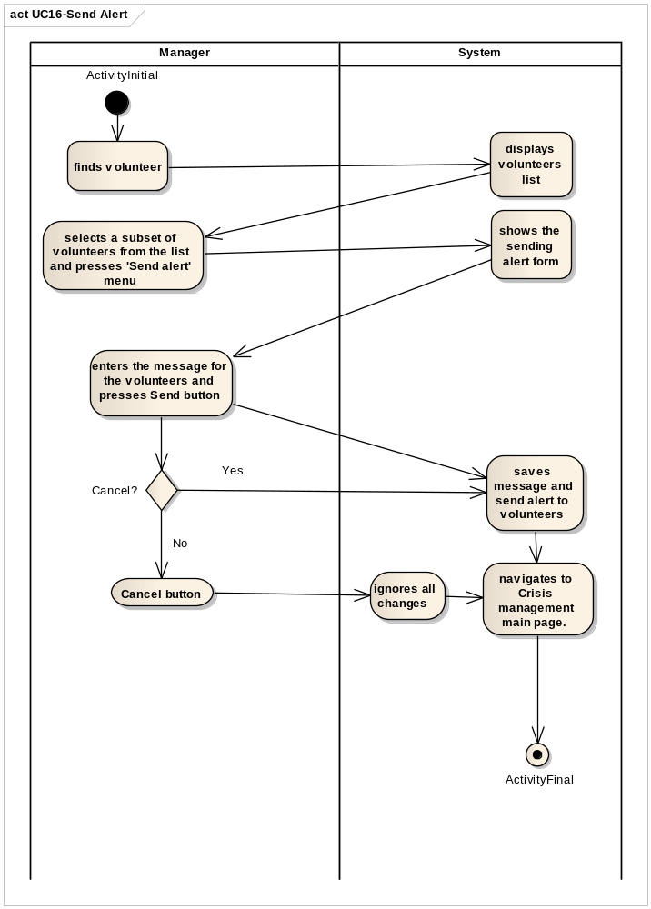

UC17-Report Incident Progress

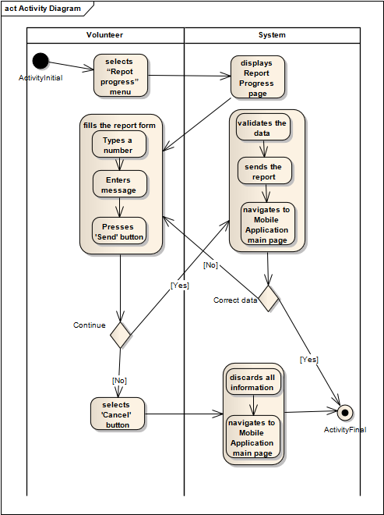

UC18-Search Volunteers
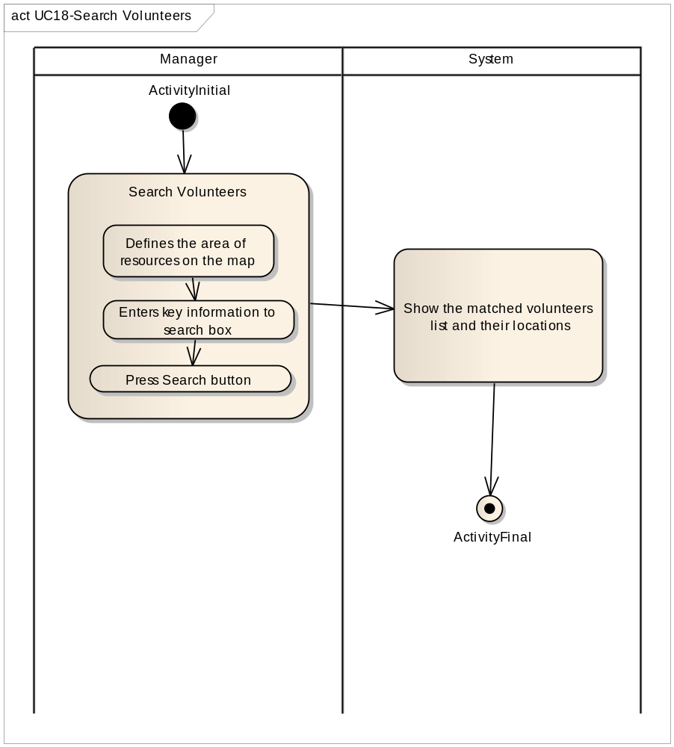

UC19-View Volunteers’ Incident Report
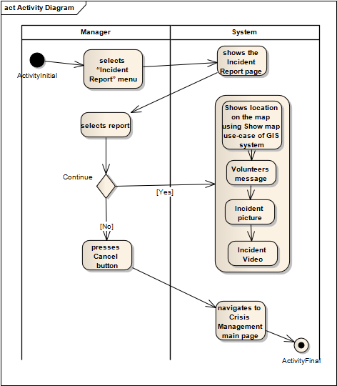

UC20-View Incident Information
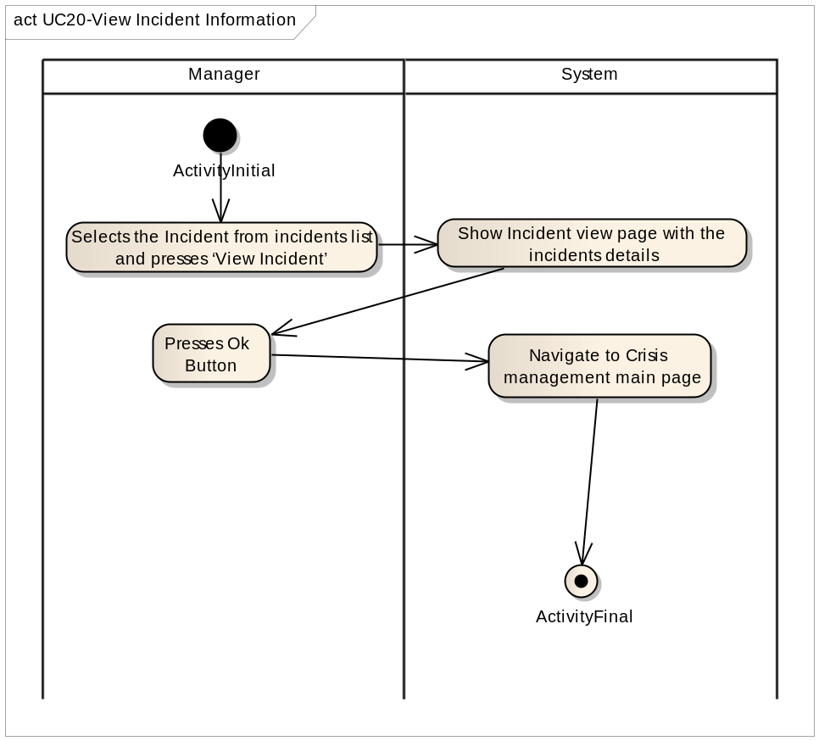

UC21-Close Incident
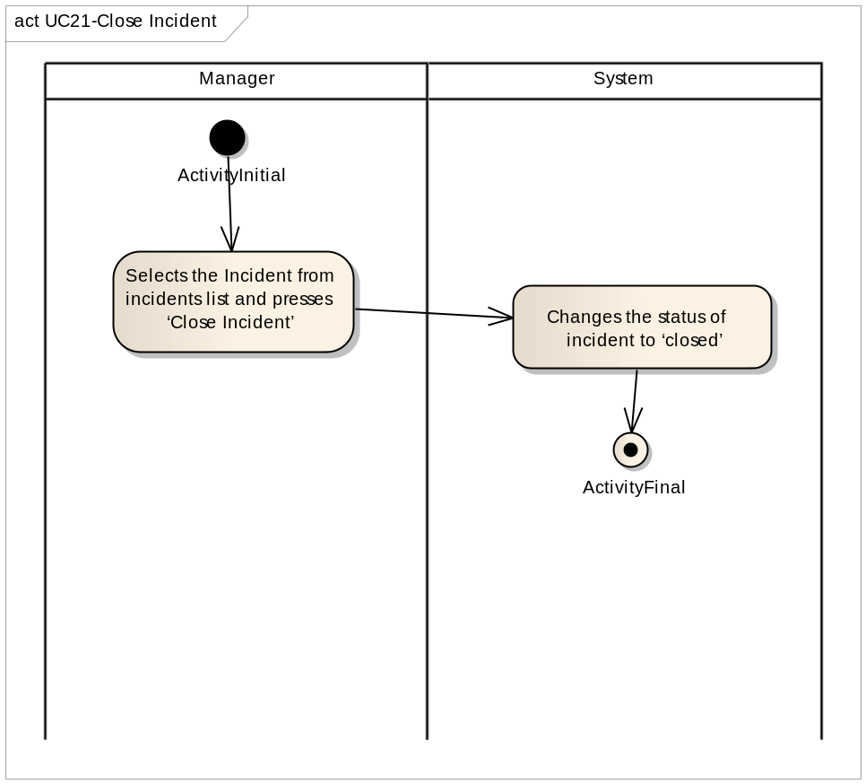

UC22-Volunteer Profile Login
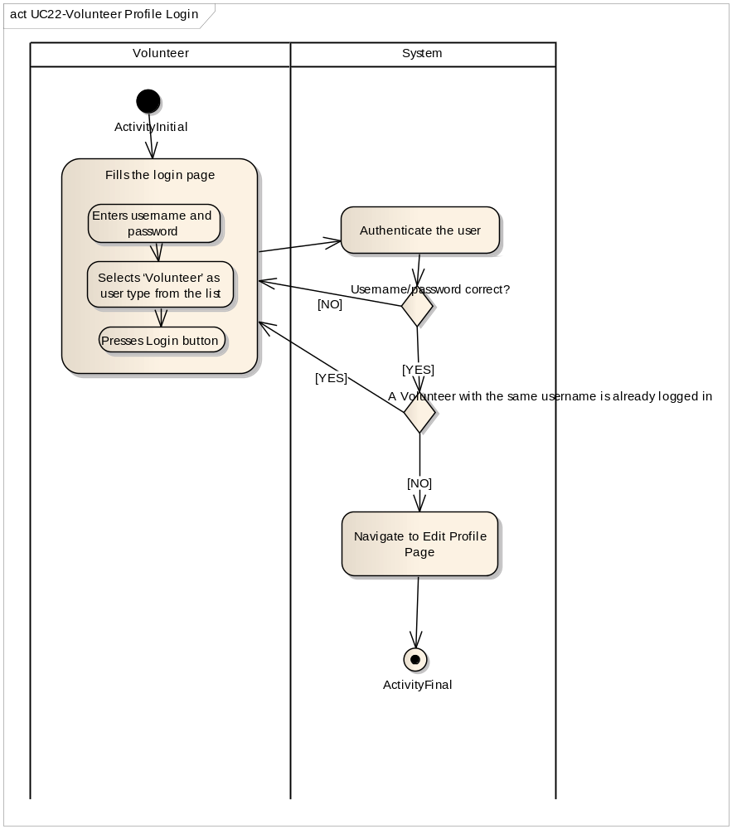

UC23-Get Alert
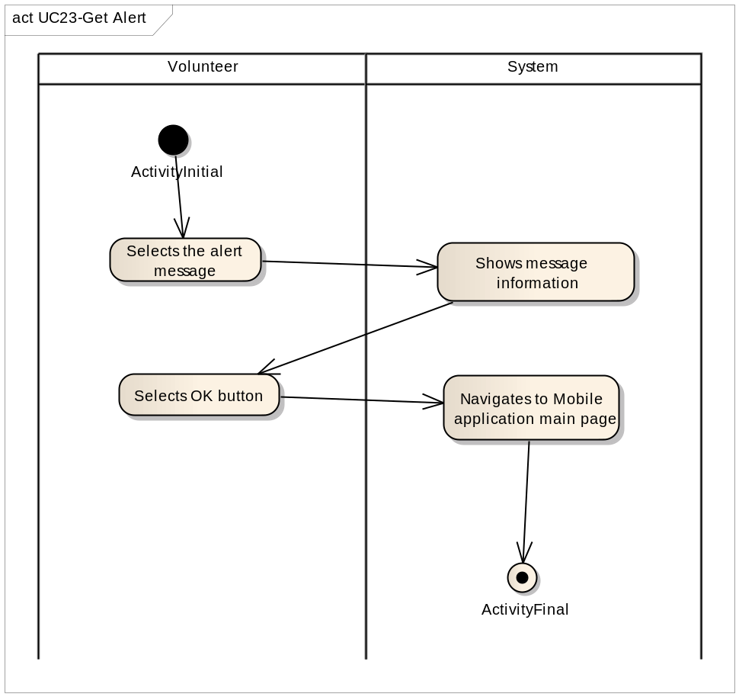

UC24-View Crisis
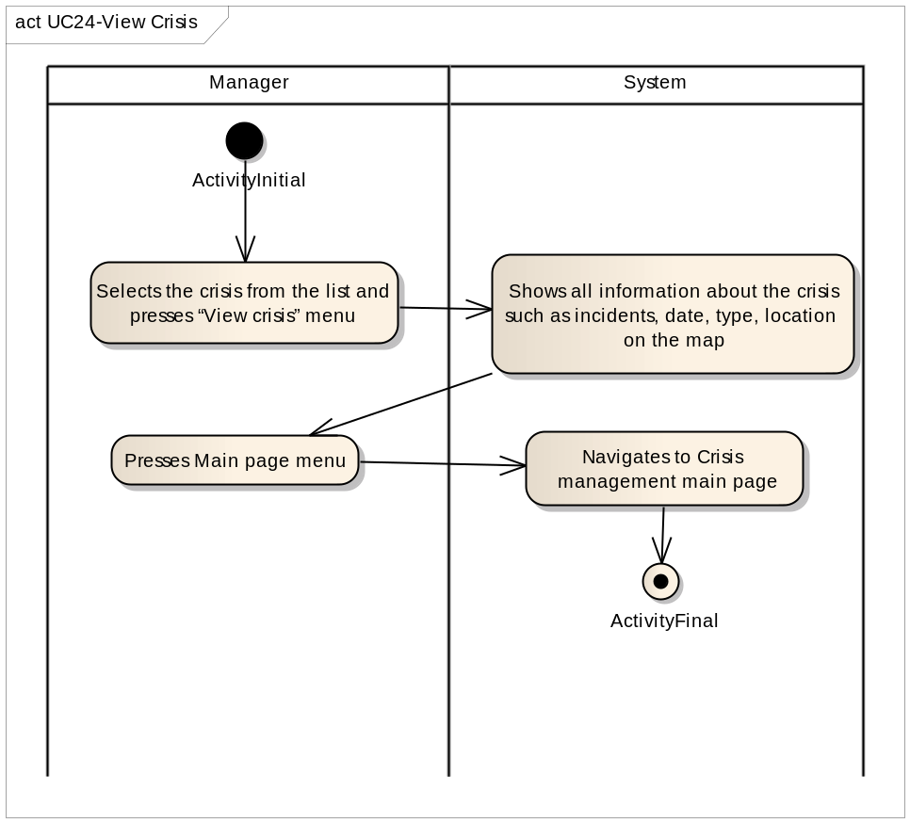

UC25-Manager profile approval
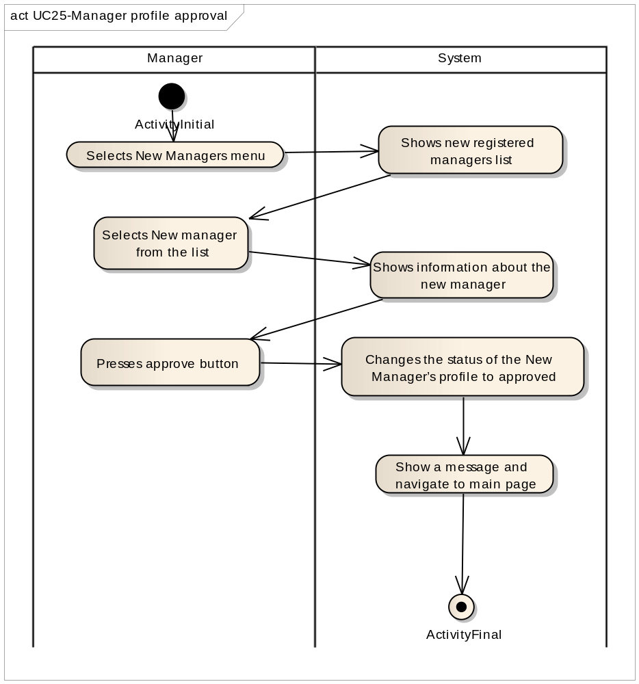
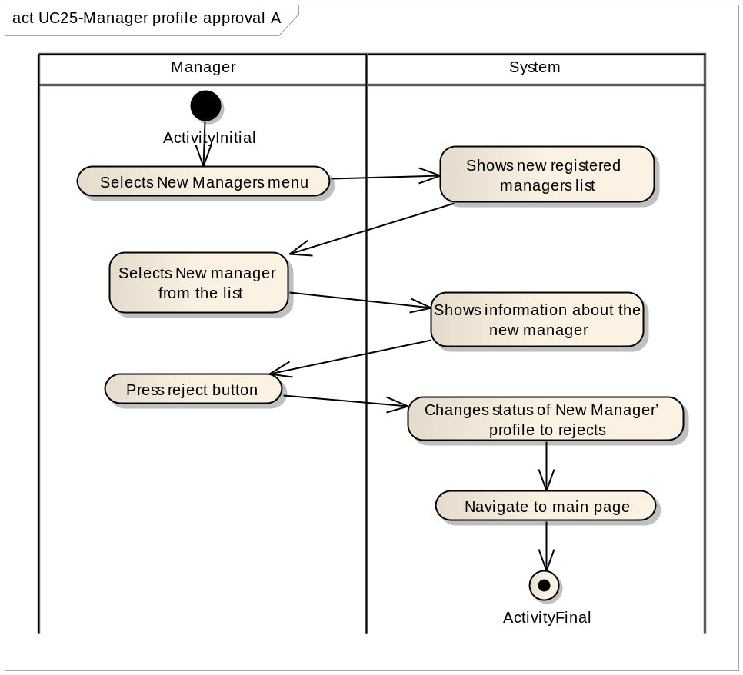

UC26-Define region on the map
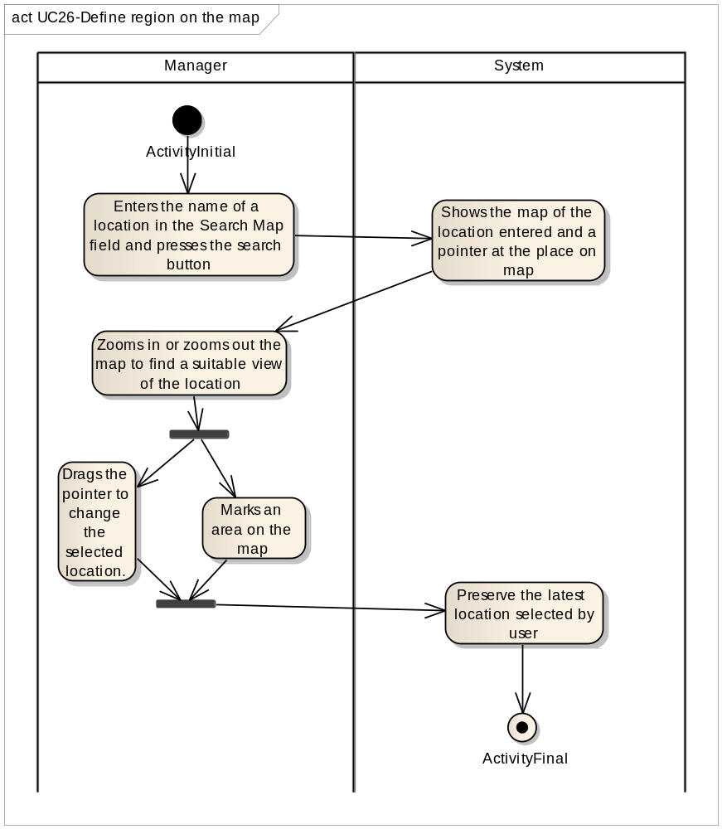

UC27-Remove request
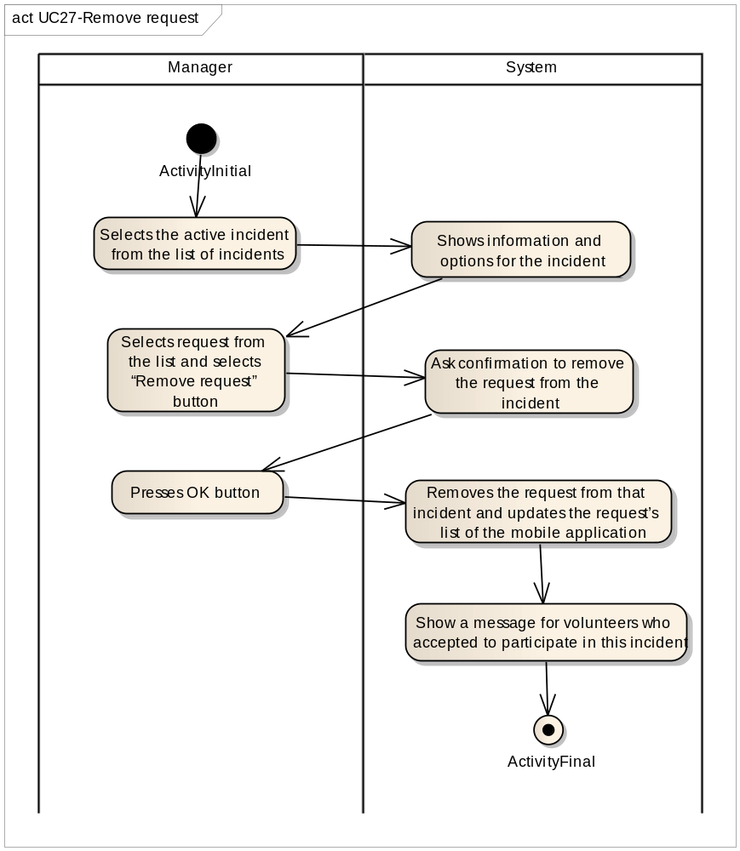

UC28-Mange Manager Profile
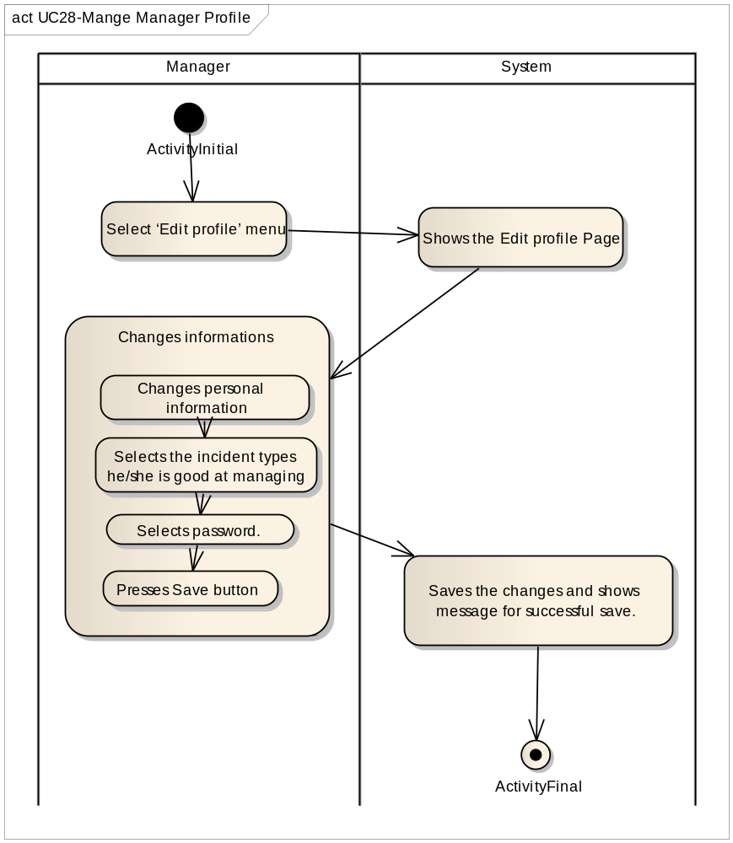

UC29-Delete Volunteer profile
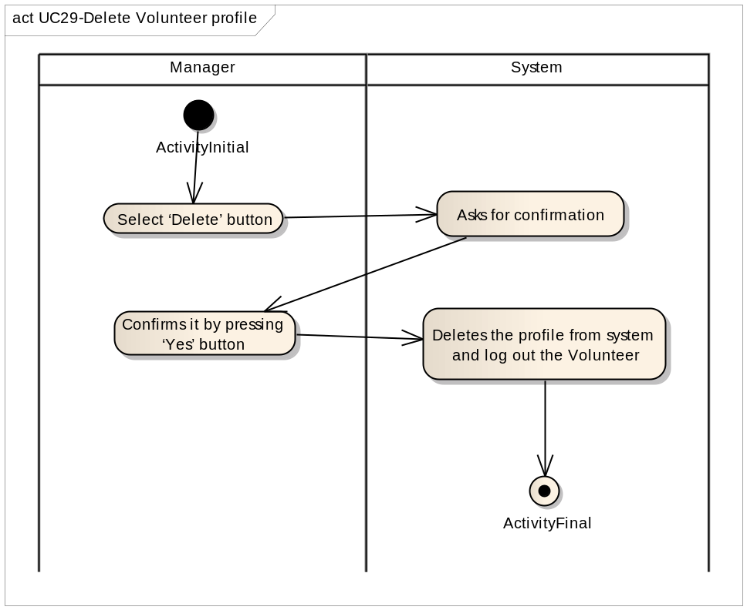
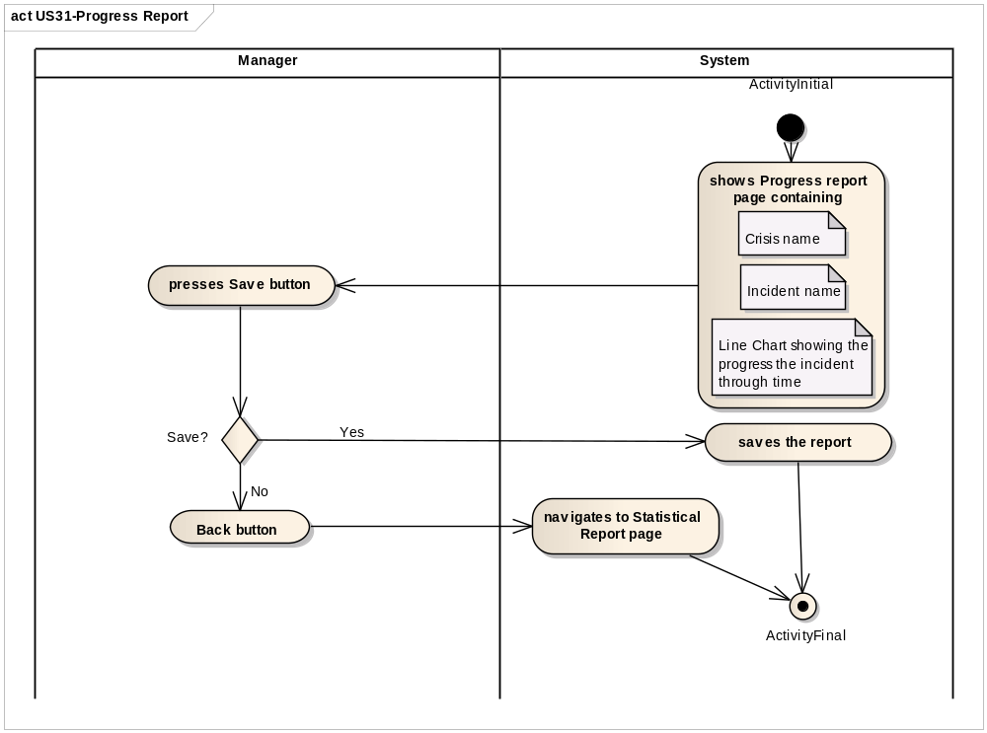
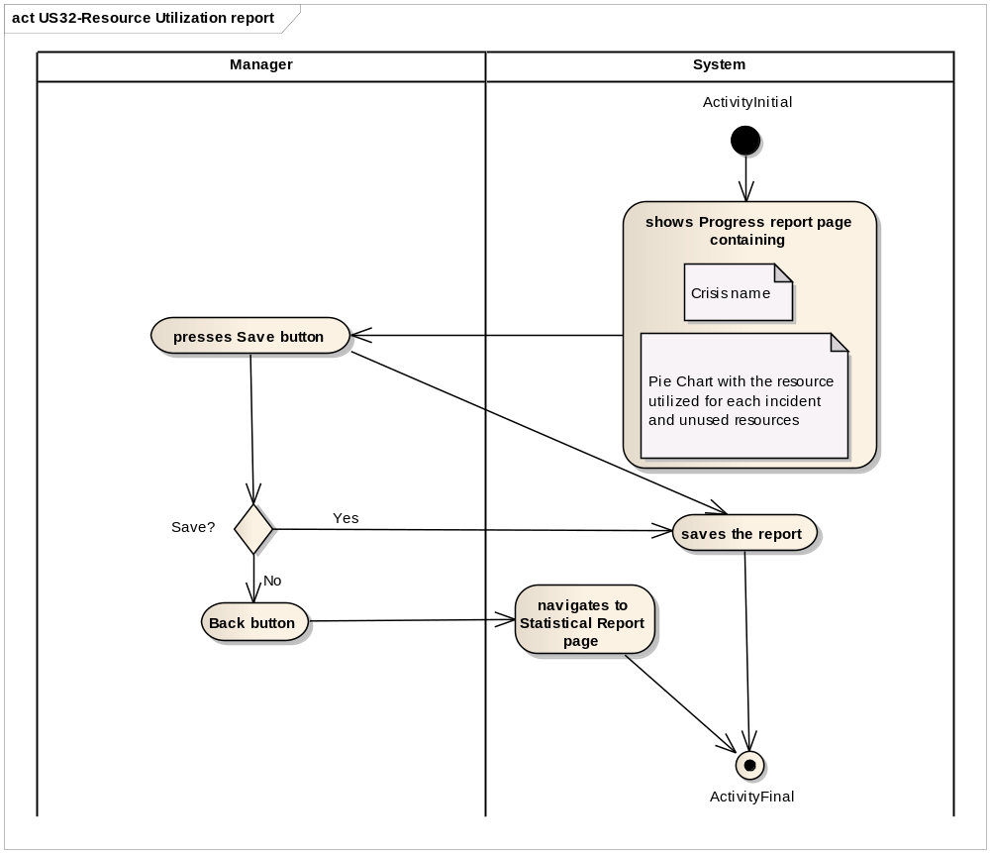
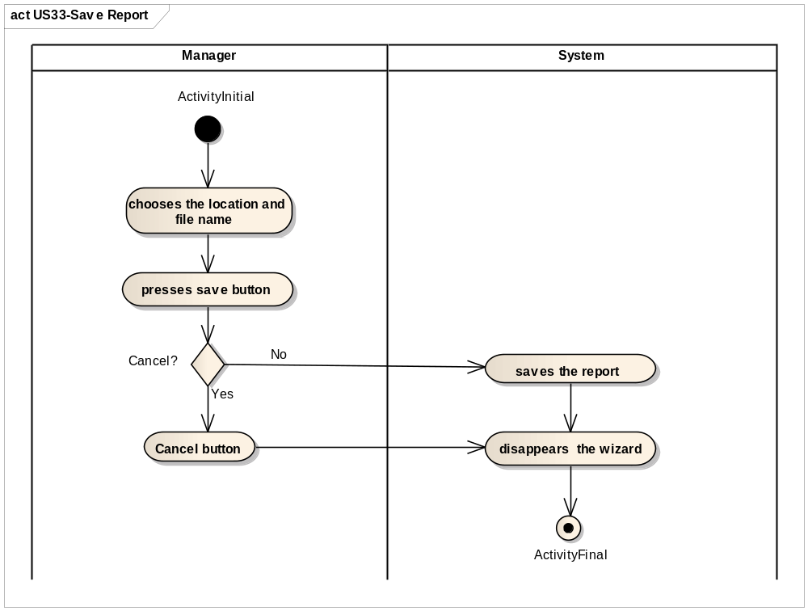
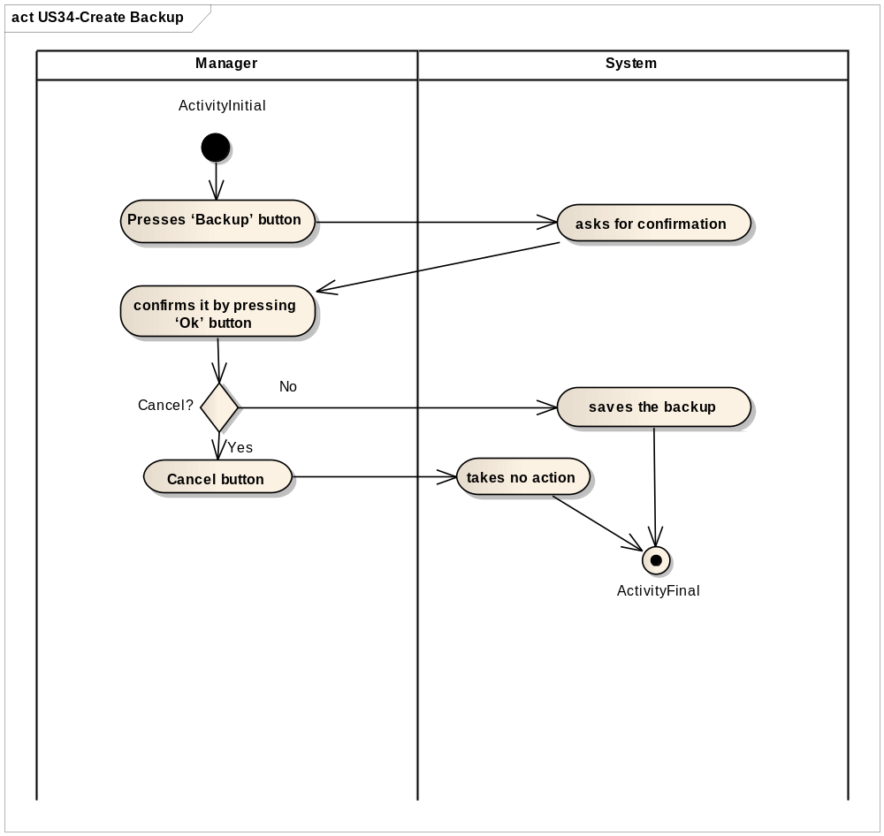
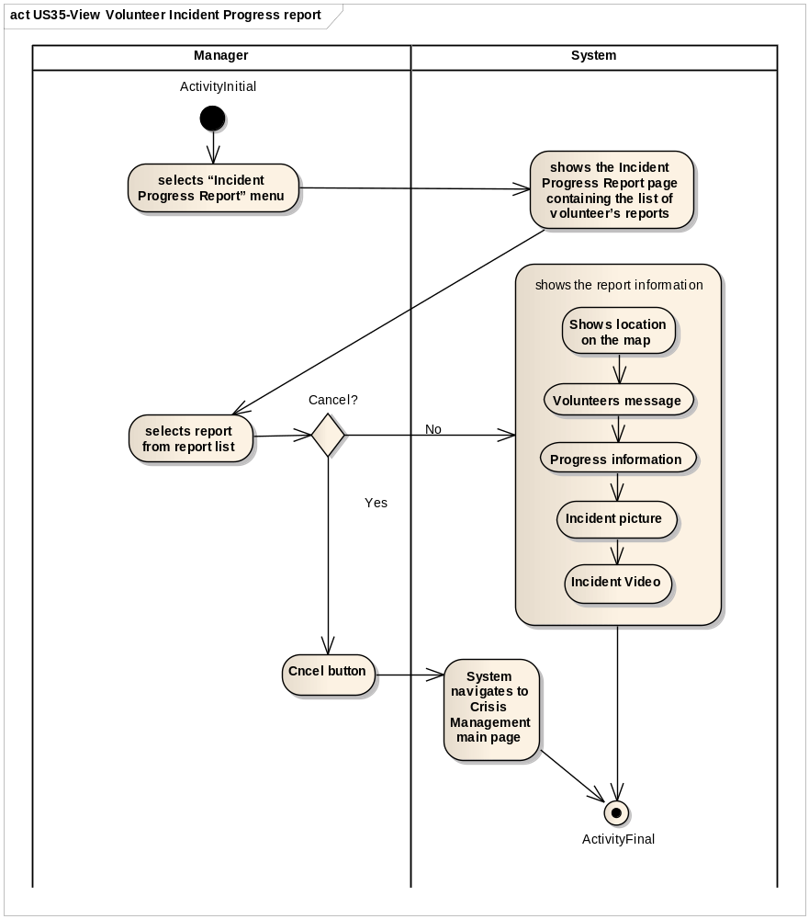

Screen Mockups

Other Functional Requirements
None

Non-Functional Requirements
Refer to Supplementary specification document.

